**Redux :-**

https://www.youtube.com/watch?v=9boMnm5X9ak&list=PLC3y8-rFHvwheJHvseC3I0HuYI2f46oAK&index=1

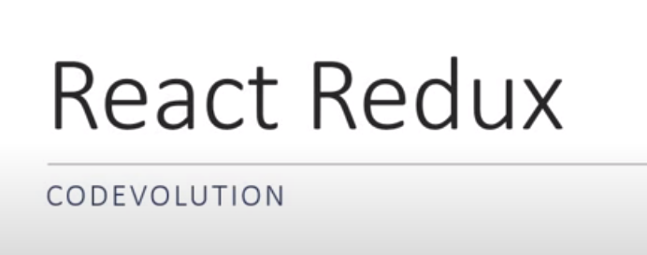

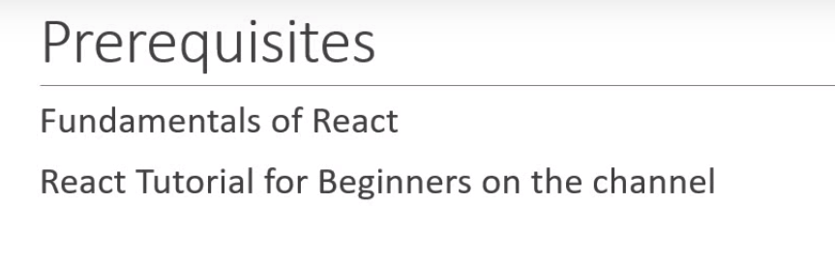

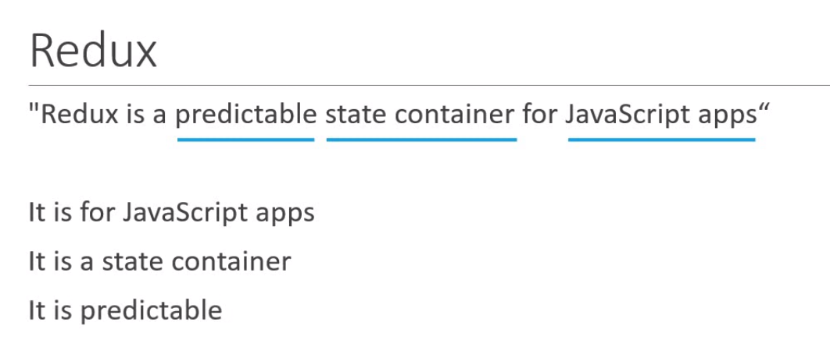

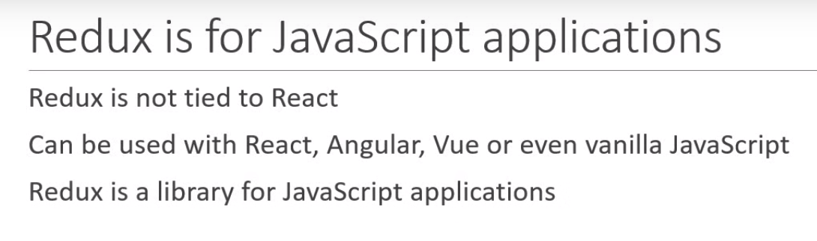

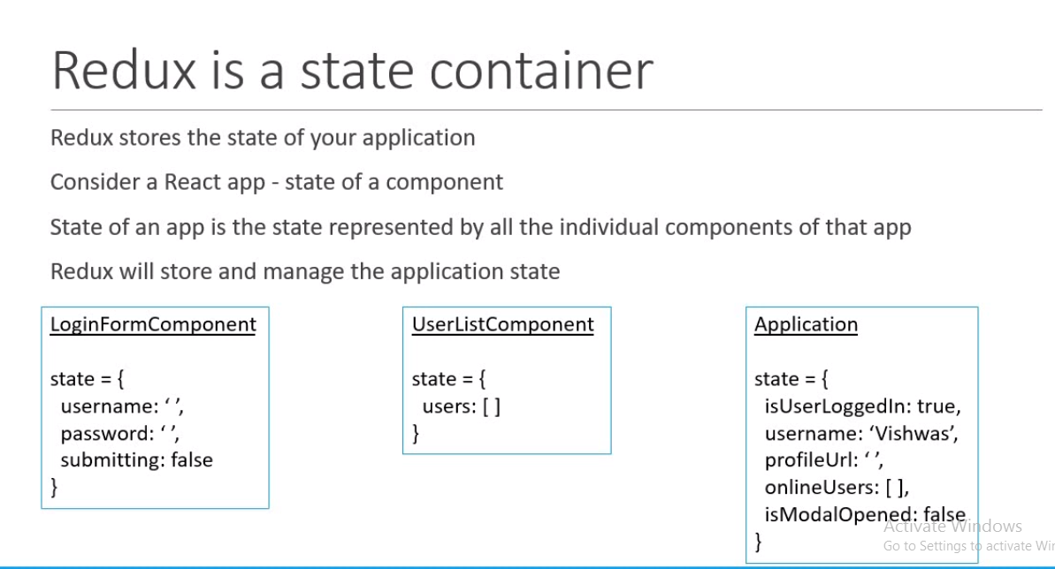

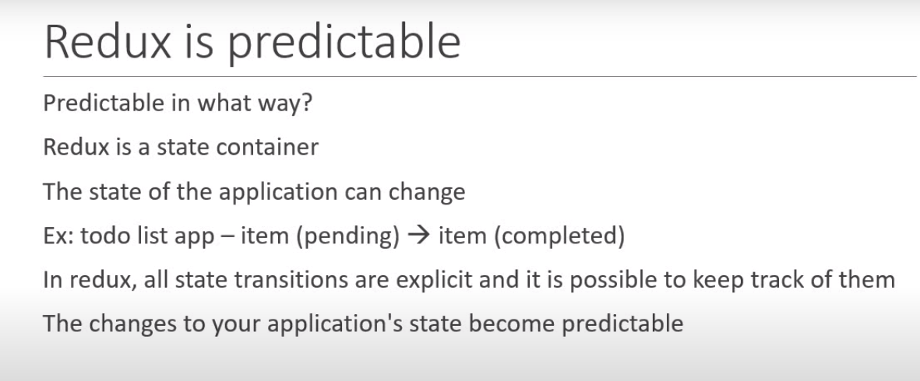

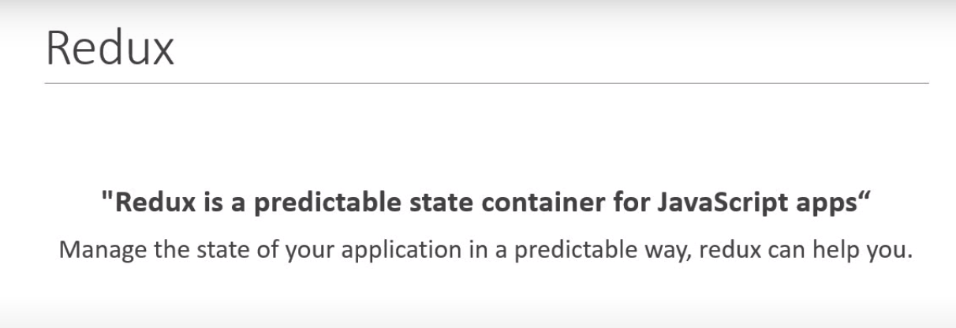

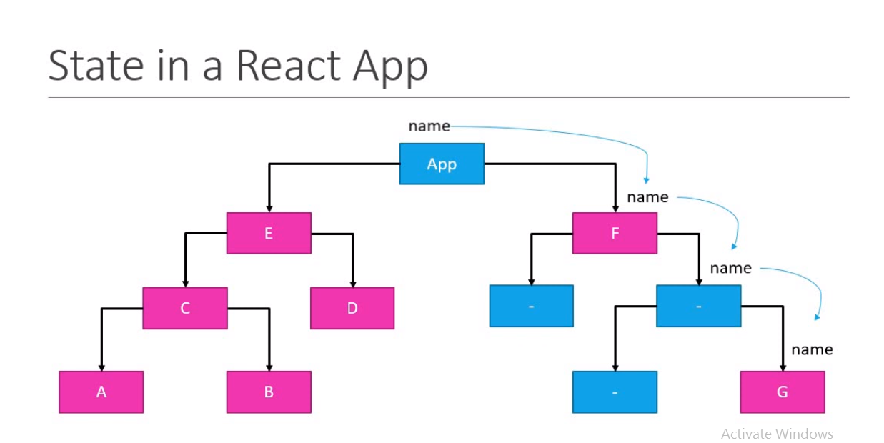

As we can see the list of components A, B C … G

So, A has the value of Name and it has to render on the component B and it has to pass to the C (A🡪C🡪B)through props.

And if D wants the value of name OF A component then again it has left from C🡪 E 🡪D

**If F and G wants.. Then again its has to through App**

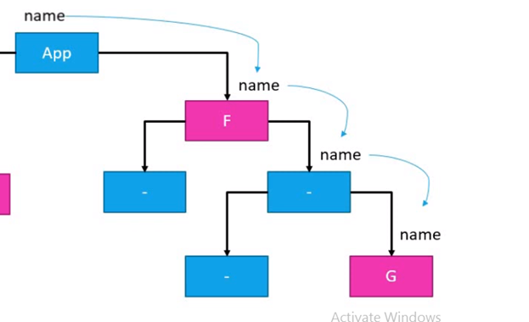

**Its difficult maintain or passing the props(state of Component A) from one component to another .**

**If the Component A value update the Name then it will pass to other components too.**

**So, redux +react came in the picture solve this issue**

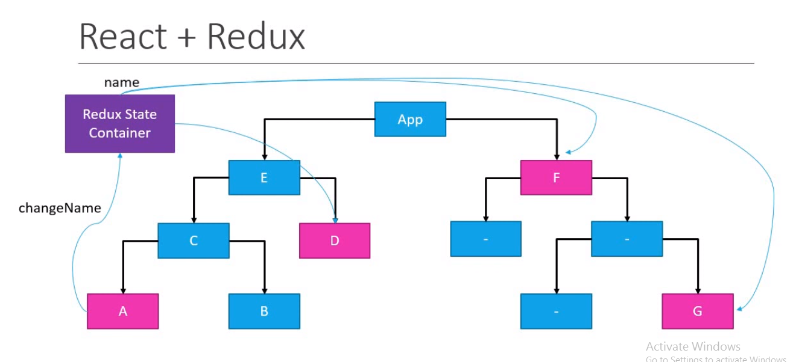

**However, we have the hook concepts like to manage : -**

[**https://www.w3schools.com/REACT/react_usecontext.asp**](https://www.w3schools.com/REACT/react_usecontext.asp)

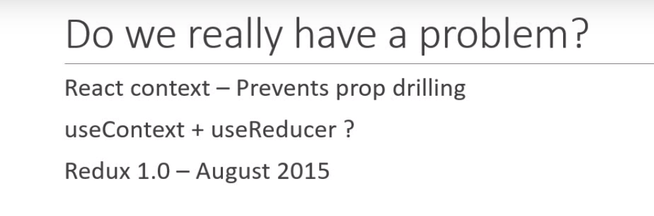

**Basic Hooks**

* useState
* useEffect
* useContext

**Additional Hooks**

* useReducer
* useCallback
* useMemo
* useRef
* useImperativeHandle
* useLayoutEffect
* useDebugValue

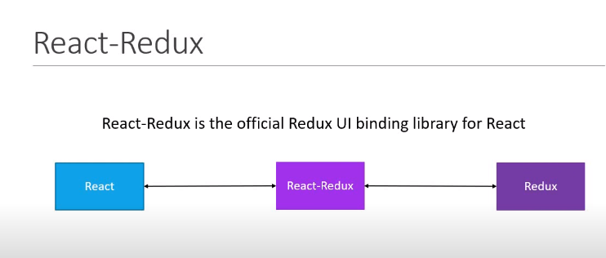

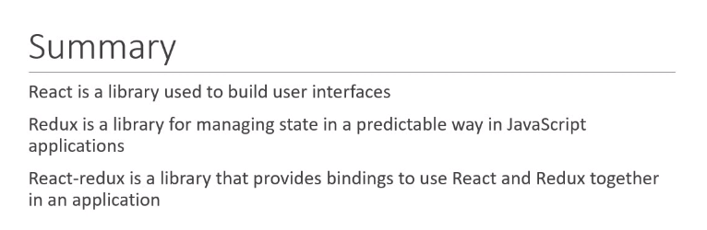

[**https://react-redux.js.org/tutorials/quick-start**](https://react-redux.js.org/tutorials/quick-start)

[**https://www.javatpoint.com/react-redux**](https://www.javatpoint.com/react-redux)

React Redux is the official React binding for Redux. It allows React components to read data from a Redux Store, and dispatch **Actions** to the **Store** to update data. Redux helps apps to scale by providing a sensible way to manage state through a unidirectional data flow model.

React Redux is conceptually simple. It subscribes to the Redux store, checks to see if the data which your component wants have changed, and re-renders your component.

React Redux is the official **UI bindings** for react Application. It is kept up-to-date with any API changes to ensure that your React components behave as expected

* It encourages good 'React' architecture.
* It implements many performance optimizations internally, which allows to components re-render only when it actually needs.

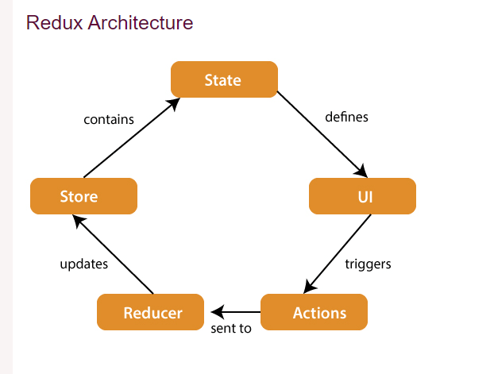

**The components of Redux architecture are explained below.**

**STORE:** **A Store is a place where the entire state of your application** lists. It manages the status of the application and has a dispatch(action) function. It is like a brain responsible for all moving parts in Redux.

**ACTION:** Action is sent or dispatched from the view which are **payloads** that can be read by Reducers. It is a pure object created to store the information of the user's event. It includes information such as type of action, time of occurrence, location of occurrence, its coordinates, and which state it aims to change.

**REDUCER:** **Reducer read the payloads from the actions and then updates the store via the state accordingly.** It is a pure function to return a new state from the initial state.

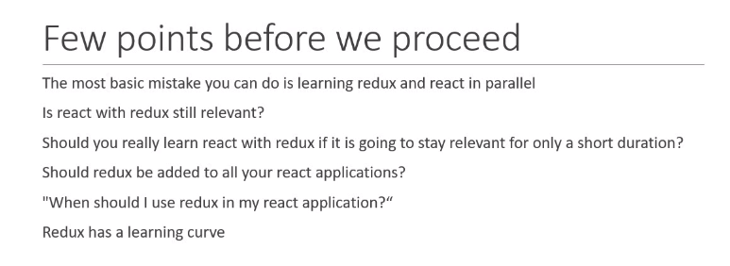

* 1. **First learn react and then redux**
  2. **Still we have to learn redux even we have concept like useContext hook- Yes we have to learn for other uses.**
  3. **In organization existing application have the redux implementation so, to make changes in the code you have to know the redux.**
  4. **Redux is required when so many components are sharng the state of its and however its depends on the organization requirement.**

[**https://www.youtube.com/watch?v=0eluxklOZVo&list=PLC3y8-rFHvwheJHvseC3I0HuYI2f46oAK&index=2**](https://www.youtube.com/watch?v=0eluxklOZVo&list=PLC3y8-rFHvwheJHvseC3I0HuYI2f46oAK&index=2)

**s1- vs-code +node and npm installed**

**s2-project folder – where package. Json file**

**s3-add the redux the dependency – npm install redux**

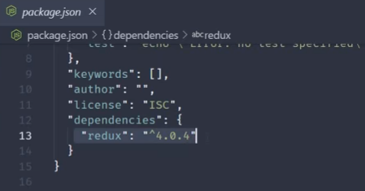

Creating the file –index.js

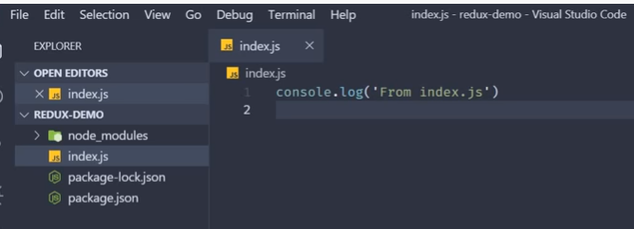

You can view the log statement in the terminal

Run the command –node index

<https://www.youtube.com/watch?v=3rlUADfuKhQ&list=PLC3y8-rFHvwheJHvseC3I0HuYI2f46oAK&index=3>

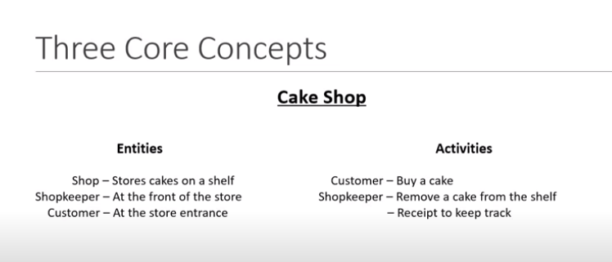

* **Shop-store,**
* **shopkeeper –reducer,**
* **customer –action**

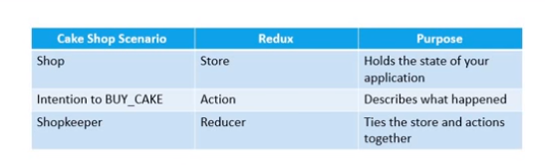

<https://www.youtube.com/watch?v=_KhGdZEWC4c&list=PLC3y8-rFHvwheJHvseC3I0HuYI2f46oAK&index=4>

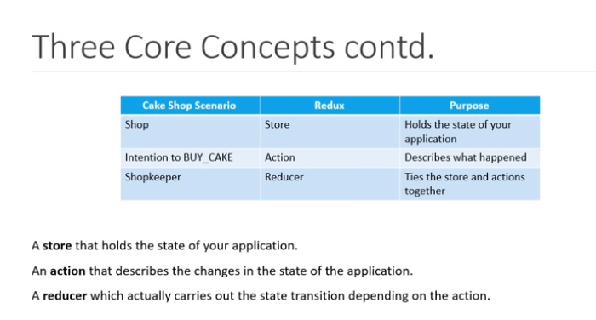

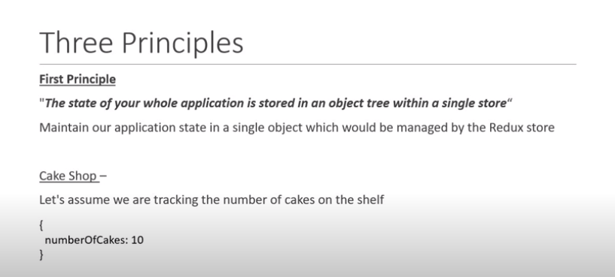

**If want to change the state in the application –as you cant do directly – you have to update your action through the shoopker syntax {type :Buy Cake}**

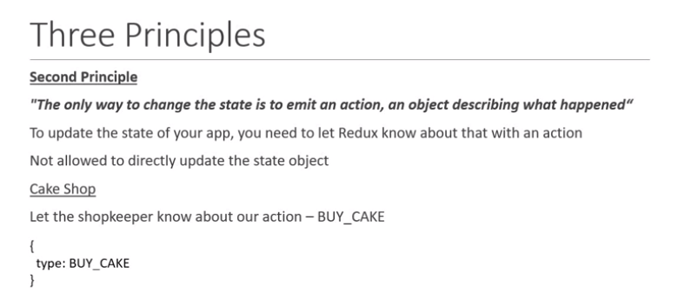

**How state is transfer from action to store.. with the help reducer**

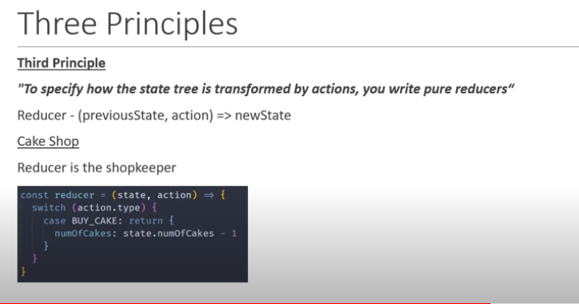It uses '**type**' property to inform about data that should be sent to the **Store**. In this folder, we will create two files: **index.js** and **index.spec.js**. Here, we have created an **action creator** that returns our action and sets an **id** for every created item.

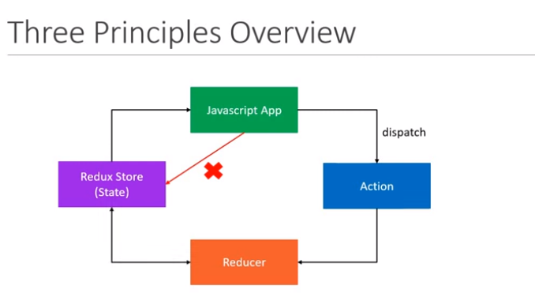

**App*** cant update is state directly to the redux store and it will emit/dispatch an Action then reducer handle the action and update the current state.**

**As soon as the value is updated then value is passed to the application -Because the app is subscribed to the redux**

[**https://www.youtube.com/watch?v=2lxCaLJ2Rbk&list=PLC3y8-rFHvwheJHvseC3I0HuYI2f46oAK&index=5**](https://www.youtube.com/watch?v=2lxCaLJ2Rbk&list=PLC3y8-rFHvwheJHvseC3I0HuYI2f46oAK&index=5)

**lets implement redux in the code.**

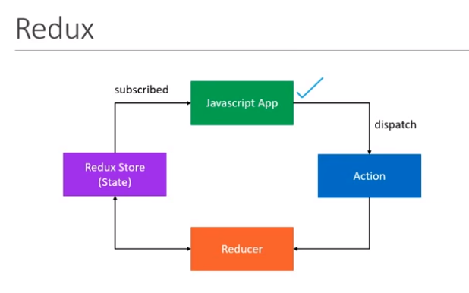

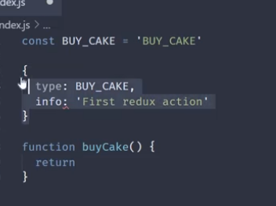

* **As you see const Buy_Cake – state**
* **{type: buy_cake}- action – is the object with type property**
* **Function buyCake(){}-action creator.. (function is the action creator )**

**Lets call the action creator in which action will be there ..**

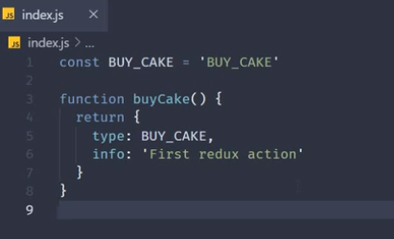

**As we implemented two parts.**

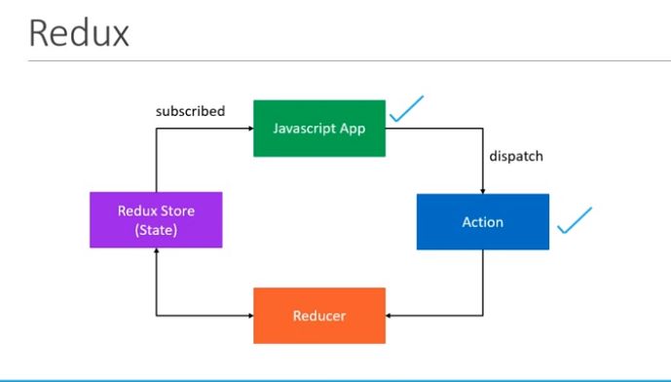

**Action describe only what happens but not how its happens.**

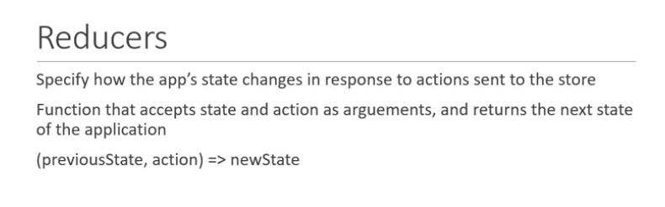

**Interms of code reducer is Fucntion that accepts the state and action as arguments.**

**For reducer want state of previous and action that now want to perform.**

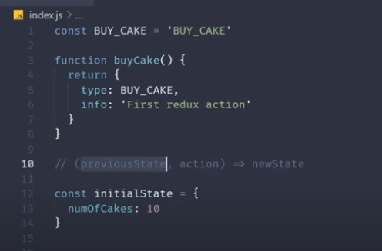

**Const intialstate – as shop open there are 10 cakes.**

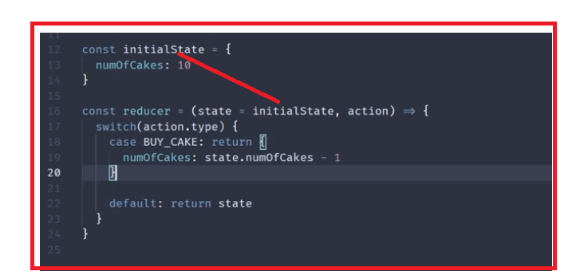

**Make a copy of the its because in real time its contains more then 1 property . As have only one property i.e numOfCakes: 10.**

**S1- create copy of the state object.**

**S2- … (spread operator)- by using …state copy of the state and other property will be unchanged**

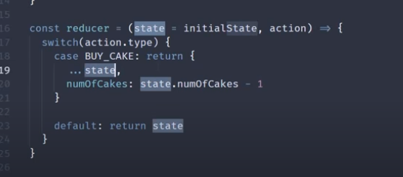

[**https://www.youtube.com/watch?v=YAevAj6X6XU&list=PLC3y8-rFHvwheJHvseC3I0HuYI2f46oAK&index=7**](https://www.youtube.com/watch?v=YAevAj6X6XU&list=PLC3y8-rFHvwheJHvseC3I0HuYI2f46oAK&index=7)

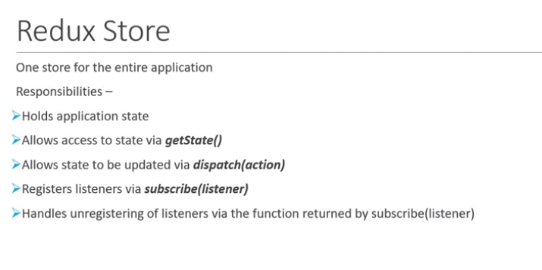

**Lets implement above concepts in the code :-**

**State of the application**

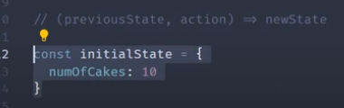

**Action**

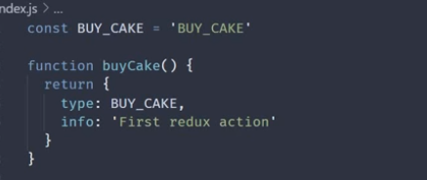

**Reducer :-**

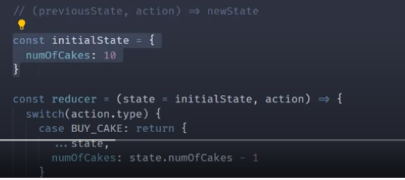

**We have to import the redux ..**

**---**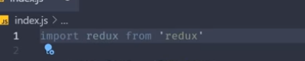

**But we have are doing on the nodejs application then want require syntax :-**

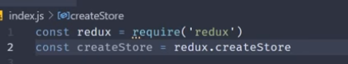

**Lets use createStore in bottom after action..**

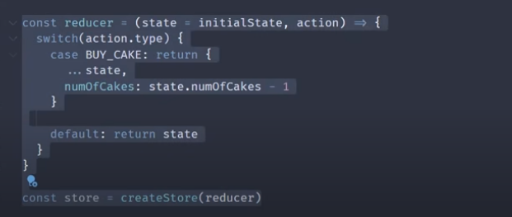

**Reducer will have previous state and action**

* **2-getState()- want the current state of the application.**

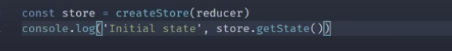

**4-**

* **subscribe or listener**

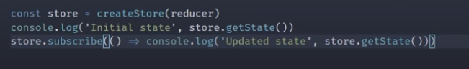

**3- Dispatch –calling the action creator ..**

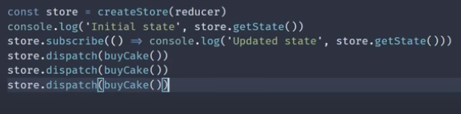

**Here is the Action creator.**



* 1. **Lets un subscribe :-**

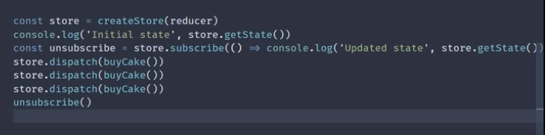

**1st –state**

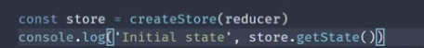

**2-state buyCake ()**

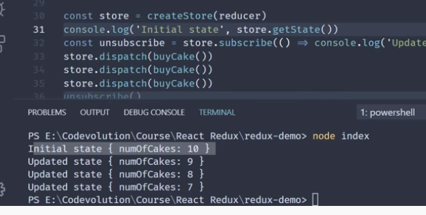

**S1-**

**S2-**

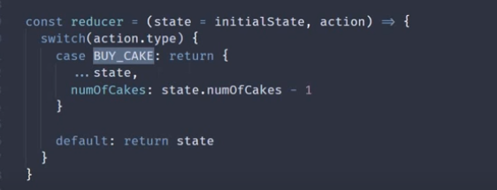

**S3-**

**No of cakes are 9**

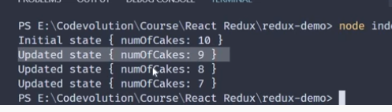

**3-state buyCake ()**

**4-state buyCake ()**

**Finally unsubscribe** – to the changes

# React Redux Tutorials - 8 - Cakes and Ice Creams

[**https://www.youtube.com/watch?v=q-SQRR-UjnY&list=PLC3y8-rFHvwheJHvseC3I0HuYI2f46oAK&index=8**](https://www.youtube.com/watch?v=q-SQRR-UjnY&list=PLC3y8-rFHvwheJHvseC3I0HuYI2f46oAK&index=8)

**Multiple Reducers :-**

**Reducer 1-cake**

**Reducer 2-ice cream**

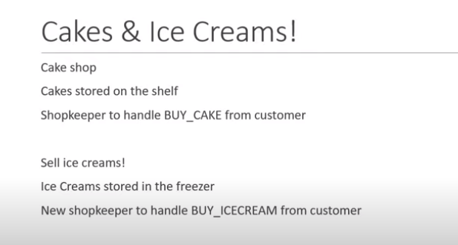

[**https://www.youtube.com/watch?v=apcda524MJA&list=PLC3y8-rFHvwheJHvseC3I0HuYI2f46oAK&index=9**](https://www.youtube.com/watch?v=apcda524MJA&list=PLC3y8-rFHvwheJHvseC3I0HuYI2f46oAK&index=9)

**cake and icecream reducers**

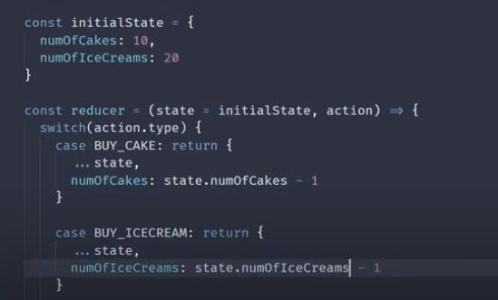

**Actions and Actions creator**

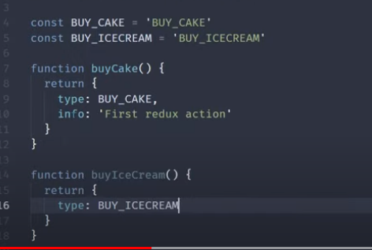

**Store- create the store , subscribe, dispatch and unsubcribe** 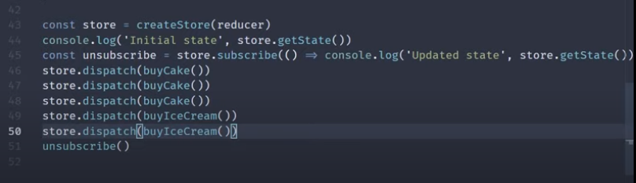

**Logs statements. .when buy cake its cakes go down and ice cream is same and vice versa**

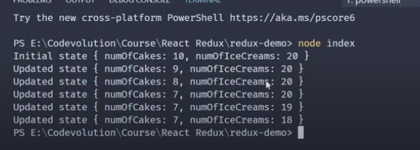

**As we have only one object for this multiple reducers and one huge function and its debug and manage and keep track of.**

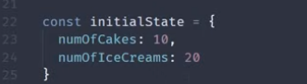

**Lets another approach of the multiple reducers :-**

**Now change the code …**

**Intial state :- cake and ice cream**

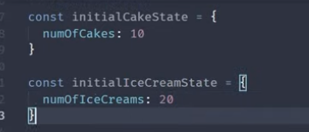

**Reducer 1- cakeReducer**

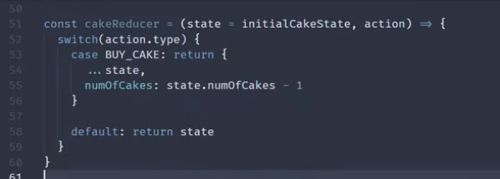

**Reducer 2- iceCreamReducer**

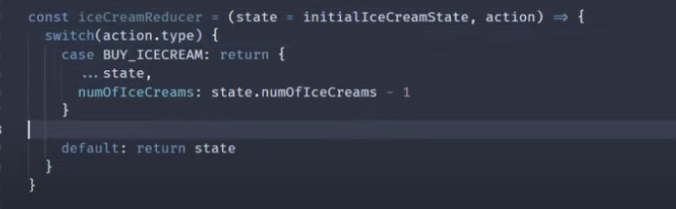

**Now we have to handle the two reducers but in the previous code.. its has only reducer**

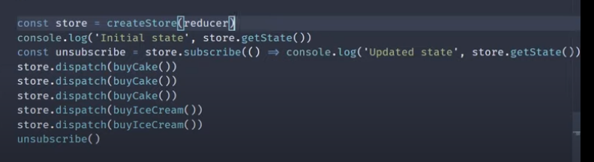

**Lets make the change in the code.**

[**https://www.youtube.com/watch?v=EKsoj96HQGY&list=PLC3y8-rFHvwheJHvseC3I0HuYI2f46oAK&index=10**](https://www.youtube.com/watch?v=EKsoj96HQGY&list=PLC3y8-rFHvwheJHvseC3I0HuYI2f46oAK&index=10)

**Lets combine the reducers and pass into the create the store()**

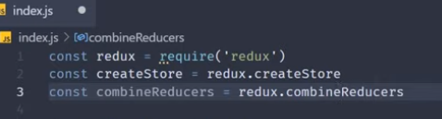

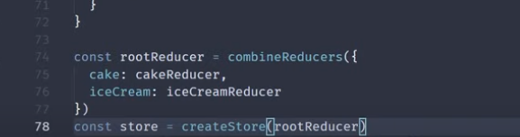

**rootReducer now hold the object and lets define key value pair like eg : -cake : cakeReducer**

**and pass in to the store = createStore(rootReducer)**

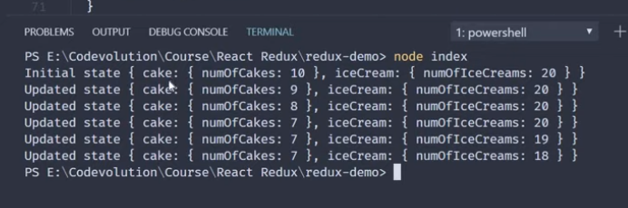

[**https://www.youtube.com/watch?v=8zPyXAWS0L4&list=PLC3y8-rFHvwheJHvseC3I0HuYI2f46oAK&index=11**](https://www.youtube.com/watch?v=8zPyXAWS0L4&list=PLC3y8-rFHvwheJHvseC3I0HuYI2f46oAK&index=11)

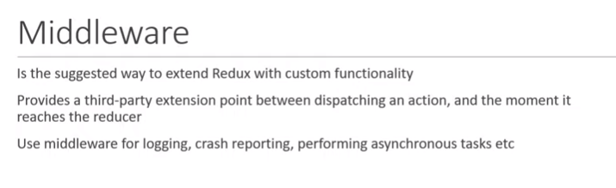

**How to use the middleware – its redux logger.. instead of defining the console.log()- we can use the library –**

**In Application**

**S1- install logger**

**S2- create logger**

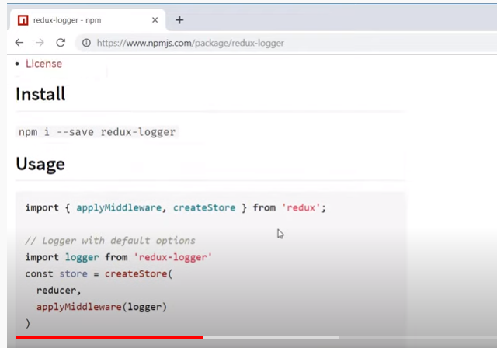

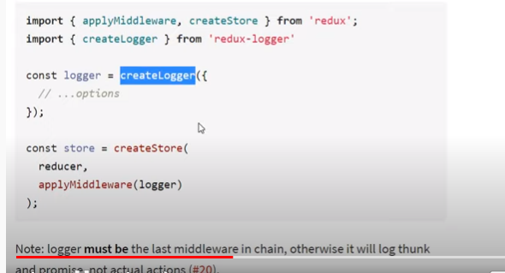

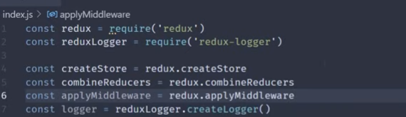

**Add –required, createLogger() and appplyMiddleware,**

**Now store in function :-**

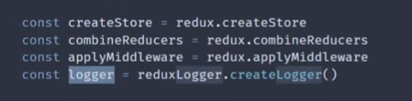

**As we only one middleware and you can as many you want to pass in the application.**

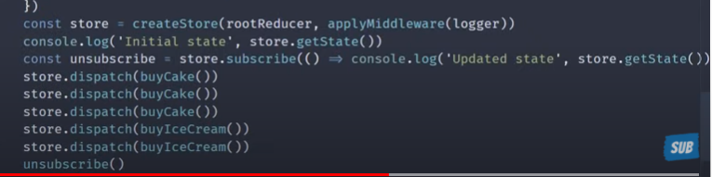

**-remove the console.log statement.**

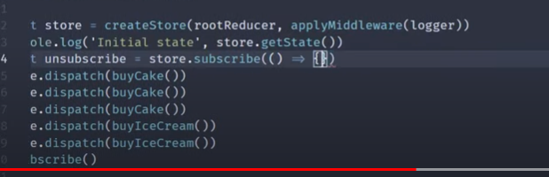

**Output:- All logs:-**

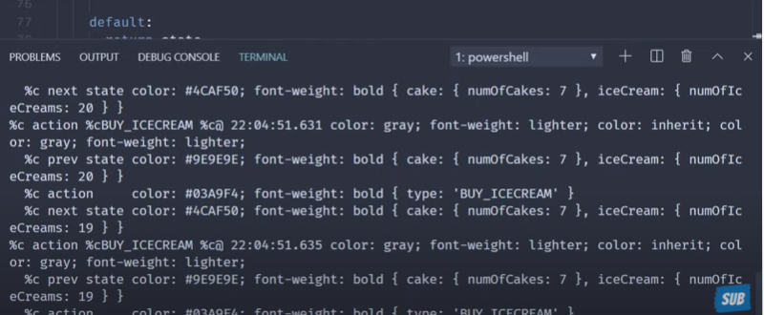

[**https://www.youtube.com/watch?v=yGyj0mSfVuk&list=PLC3y8-rFHvwheJHvseC3I0HuYI2f46oAK&index=12**](https://www.youtube.com/watch?v=yGyj0mSfVuk&list=PLC3y8-rFHvwheJHvseC3I0HuYI2f46oAK&index=12)

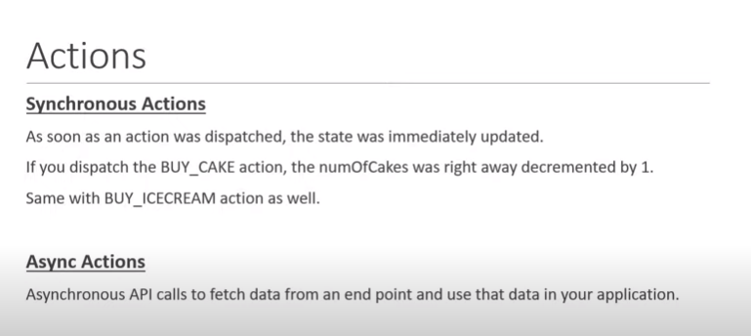

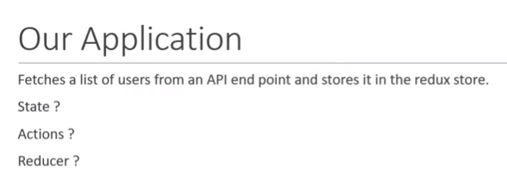

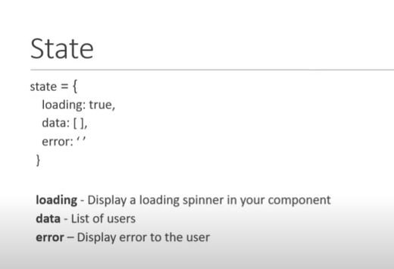

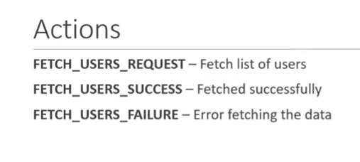

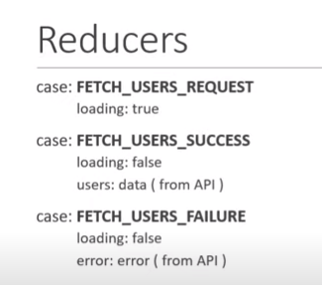

**Lets create the new application asychAction.js**

**State:-**

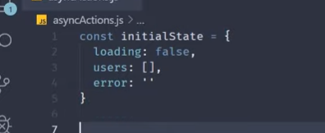

**Let create the Action-type and Action Creator-function**

**Lets create the const- for Actions**

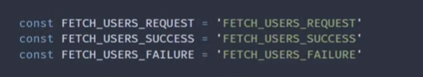

**Action 1**

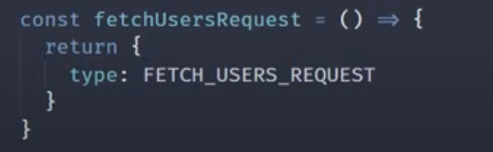

**Action 2 and 3**

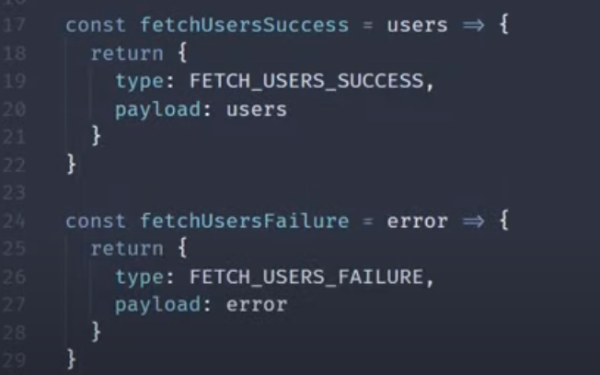

**Reducer- As we are defining one object and having the 3 properties i.e loading, users and error in one Reducer**

**As we using the const here in reducers too**



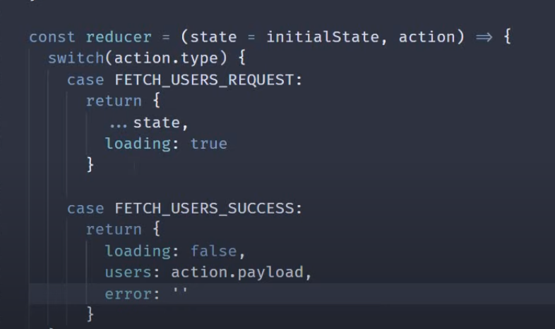

**If request is fail.. ..**

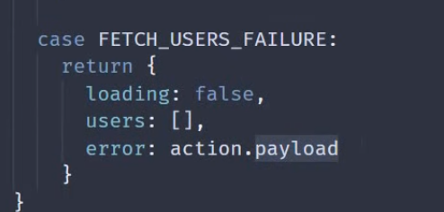

**Flow of Action and Reducers**



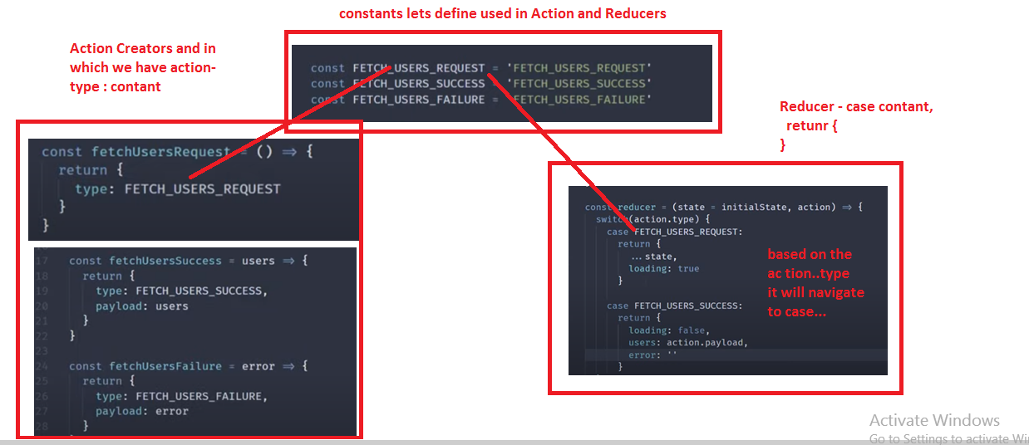

**Now create the required- redux and redux.createStore**

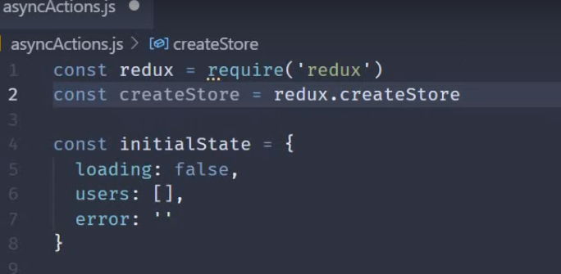

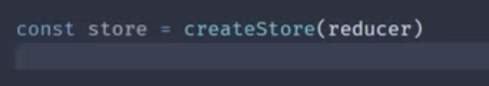

**Now call the Api Call now..**

[**https://www.youtube.com/watch?v=z2XCUu2wIl0&list=PLC3y8-rFHvwheJHvseC3I0HuYI2f46oAK&index=13**](https://www.youtube.com/watch?v=z2XCUu2wIl0&list=PLC3y8-rFHvwheJHvseC3I0HuYI2f46oAK&index=13)

**How to making the Api when we are working the Redux**

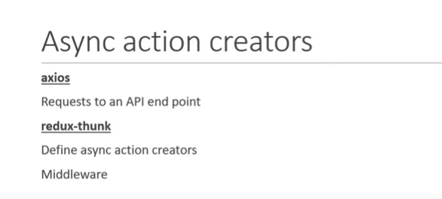

**Install two packages**

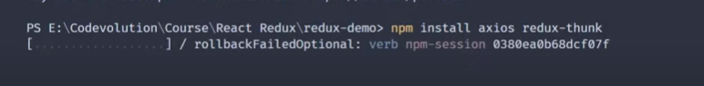

**Apply redux-thunk middle ware to redux store.**

**Create conts -ApplyMiddleware and redux-thunk**

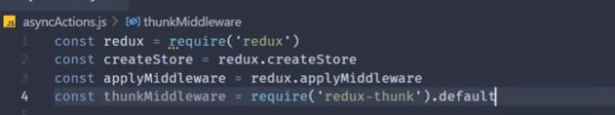



**Lets define axios too**

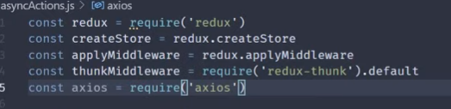

**As we know the action create will return the action, but we are implementing the middle ware –redux-thunk return the function instead of action object**

**Case 1- simple action creator with action type object.**

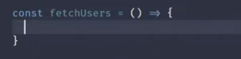

**Case 2- action creator with return type function- dispatch the nessary fuction. instead of object –**

**Axios request:-**

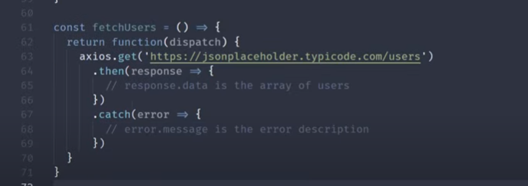

**Before fire the get method.. lets dispatch the fetch the user request.**

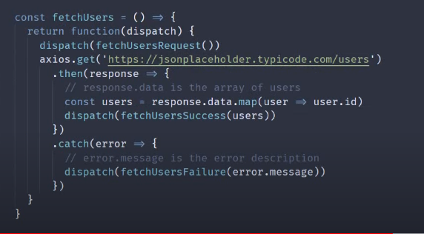

**As we define dispatch(fetchUserRequest()) before axios.get()- Dispatch(fetchUserSuccess(users)) after axios.get().**

**As we uset the map and get only id from the list of users.**

**Now create the store and call the reducer in it.**

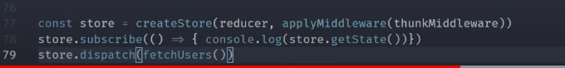

**Action Creator – with function return – by adding the ThunkMiddleWare –redux**

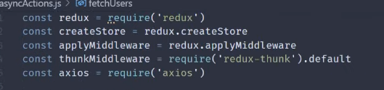





**Output :-**

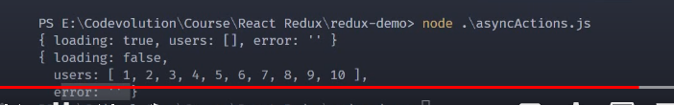

**If we pass the invalid url - first we will –default intial state**

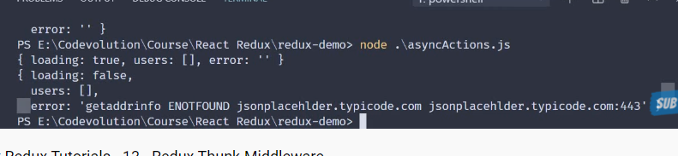

[**https://www.youtube.com/watch?v=0bVP5cYhMuU&list=PLC3y8-rFHvwheJHvseC3I0HuYI2f46oAK&index=14**](https://www.youtube.com/watch?v=0bVP5cYhMuU&list=PLC3y8-rFHvwheJHvseC3I0HuYI2f46oAK&index=14)

# React Redux –Library

# 

# LETS CRATE THE APP-react-redux -demo

**Rfce –fuctional component**

**CakeContainer in component**

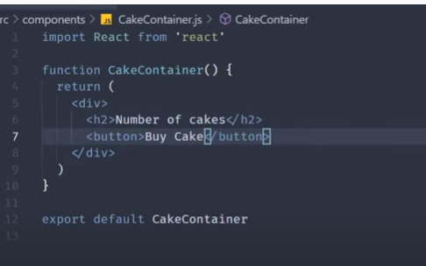

**Define the cakeContainer in the App.js**

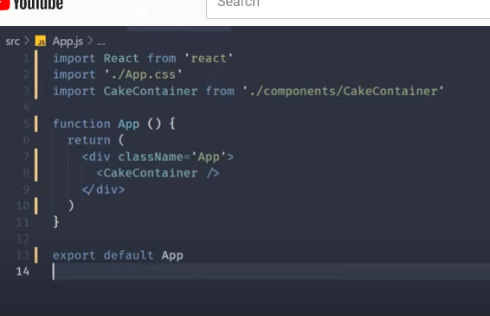

**Output:-**

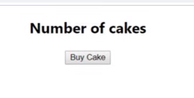

**Lets add the actions to the cake shop application**

[**https://www.youtube.com/watch?v=g5l8xu6i4XQ&list=PLC3y8-rFHvwheJHvseC3I0HuYI2f46oAK&index=15**](https://www.youtube.com/watch?v=g5l8xu6i4XQ&list=PLC3y8-rFHvwheJHvseC3I0HuYI2f46oAK&index=15)

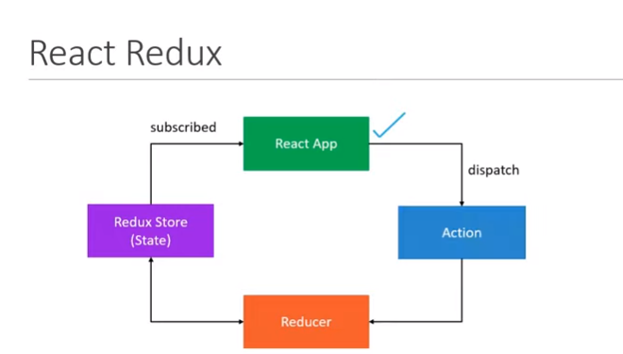

**As we set the application and Lets define now actions and action creators..**

**Lets create the redux folder in the src folder**

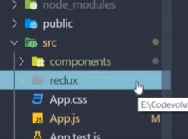

**Redux-cakes-cakeActions.js and cakeTypes.js(which hold the constants)**

**cakeActions.js- import the actionType .js**

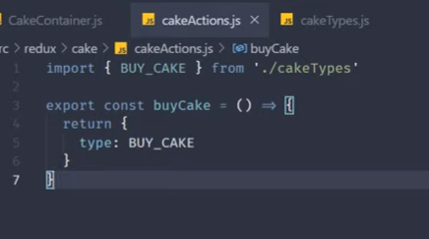

**cakeTypes.js(which hold the constants)- export const**

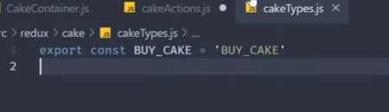

**Now lets export the action creator**

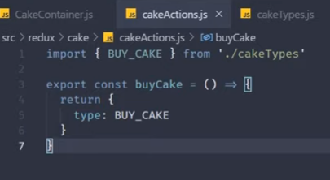

[**https://www.youtube.com/watch?v=dm_2AANfdfA&list=PLC3y8-rFHvwheJHvseC3I0HuYI2f46oAK&index=16**](https://www.youtube.com/watch?v=dm_2AANfdfA&list=PLC3y8-rFHvwheJHvseC3I0HuYI2f46oAK&index=16)

**Now lets implement the Reducer :-**

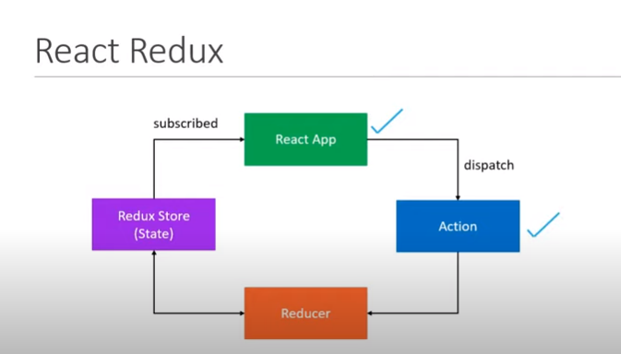

**Now lets create cakeReducers in the Cake Folder in Redux folder**

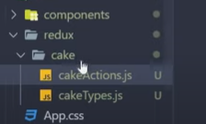

**cakeReducer.js –**

**s1-set initial values and pass those value to reducer and even the action,**

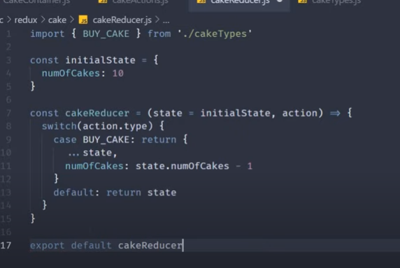

**In the above code …state is the spread operator which copy the state. Based on the action.type it will pass to the Buy.Cake: return {…. State and perform logic like reduce the cake by 1} and finally export default cakeReducer.**

**Lets Create the Redux Store : -**

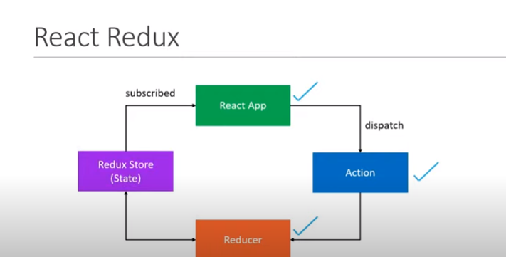

**Lets create the store :-**

**Lets implement basic step of the store..**

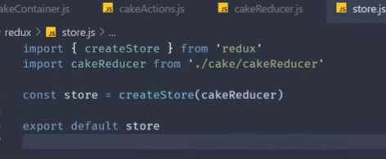

**Now provide this redux store to the react application. So, go to the App.js and import the provider from react-redux.**

**Even import the store.js in the App.js**

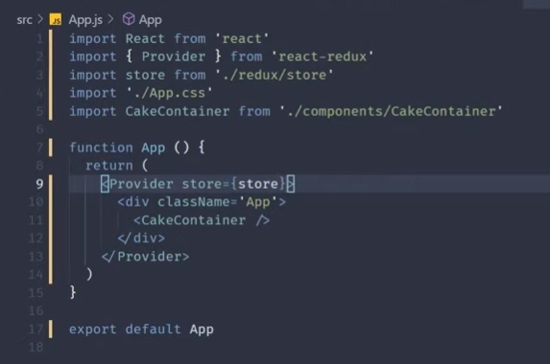

**As we are proving the <Provider Store = {store}>- for every component in the application component tree.**

**How to dispatch the action and subscribe the components.**

[**https://www.youtube.com/watch?v=gFZiQnM3Is4&list=PLC3y8-rFHvwheJHvseC3I0HuYI2f46oAK&index=18**](https://www.youtube.com/watch?v=gFZiQnM3Is4&list=PLC3y8-rFHvwheJHvseC3I0HuYI2f46oAK&index=18)

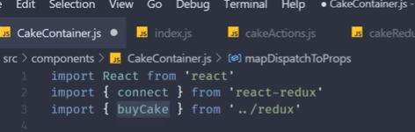

**Lets create the index.js and export the action class. buyCake**

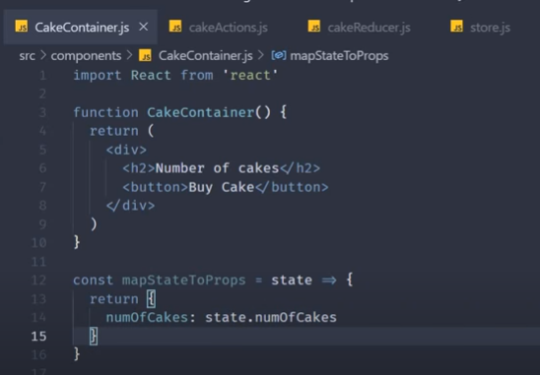

**S1- in big application there is folder selectors**

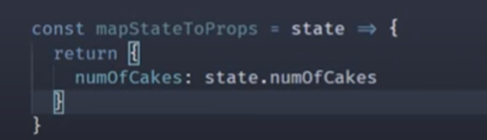

**S1- will get the no of cakes- mapStateToprops**

**S2-mapDispatchToProps-**

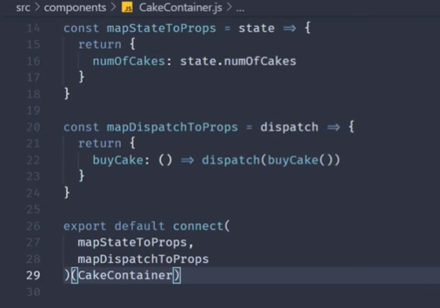

**ActiontType-BuyCake**



**Lets make the change in the code :-**

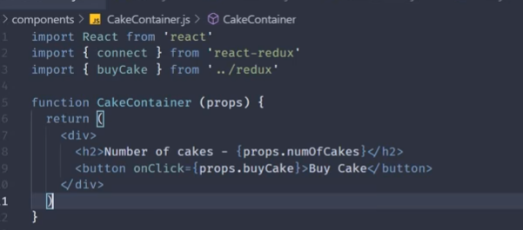

**Flow : -**

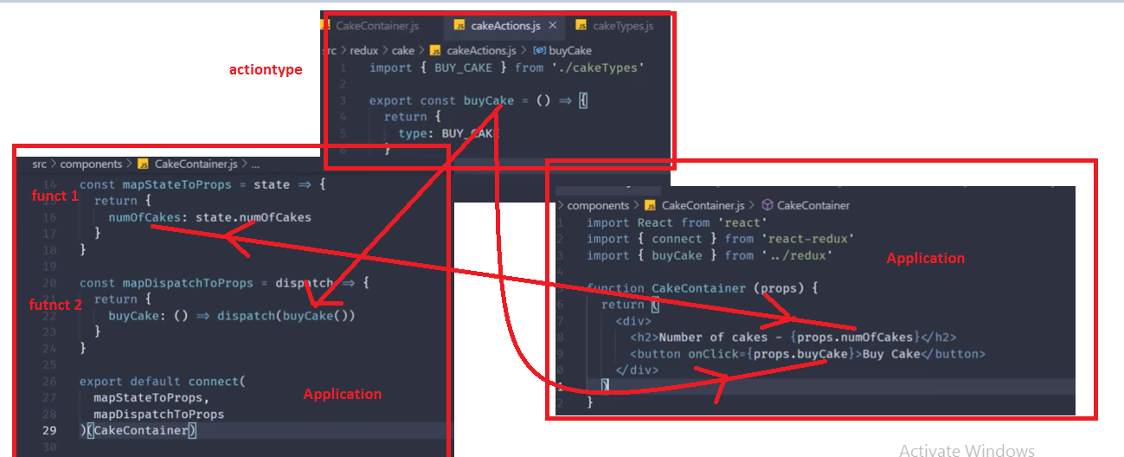

**When you click on by BuyCake this action will called and passed to reducer where its reduce to -1 and this update is updated in the store and store is configured in the Application by provider and finally we get the current state of the application by state - props.numOfCake.**

**BuyCake() 🡪Reducer(intaila state ,action) ->Store(reducer, middlerware(optional for logger and thunk for api)) ->App Provider store = {store}.**

**Output**

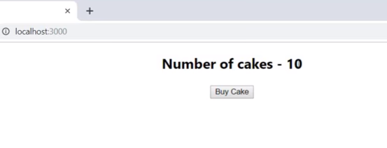

**To get the state of the Application get the from the redux –state – as we map state.numOfCakes**

**Function 1- mapStateToProps is convention name..**

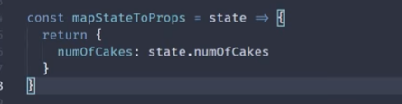

**To get the dispatch the ActionCreator.**

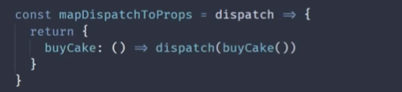

**All these can possible by connect function like – connecting the mapStateToProps and mapDispatchToProps with the CakeConatiner**

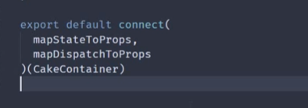

[**https://www.youtube.com/watch?v=wc08G6g4yyA&list=PLC3y8-rFHvwheJHvseC3I0HuYI2f46oAK&index=19**](https://www.youtube.com/watch?v=wc08G6g4yyA&list=PLC3y8-rFHvwheJHvseC3I0HuYI2f46oAK&index=19)

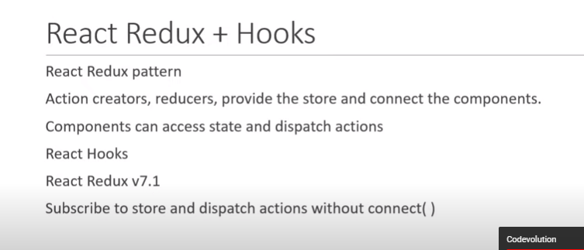

[**https://www.youtube.com/watch?v=oKvF8jcSwIg&list=PLC3y8-rFHvwheJHvseC3I0HuYI2f46oAK&index=20**](https://www.youtube.com/watch?v=oKvF8jcSwIg&list=PLC3y8-rFHvwheJHvseC3I0HuYI2f46oAK&index=20)

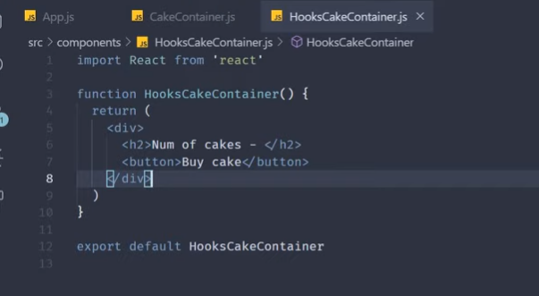

**Now lets use the selector and we have used mapsStatetoProps which is equal to selector**

**Selector is used to hold the state of the application from react-redux.**

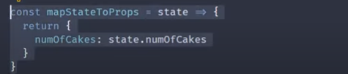

**Lets use the selector useSelector –hook**

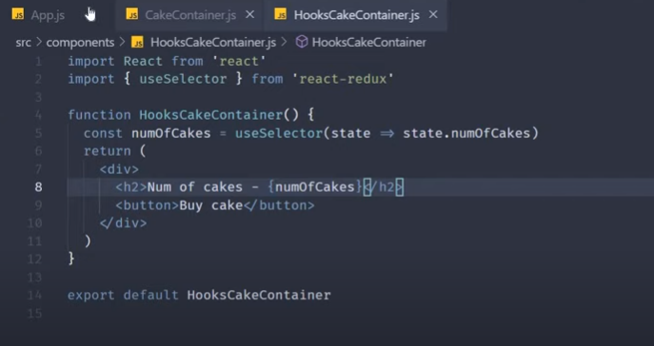

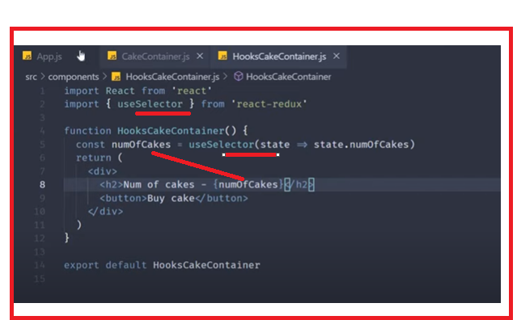

**Lets impor the HooksCakeContainer in the App.js**

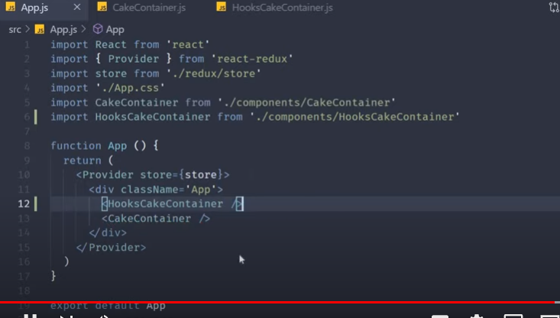

**Output : -**

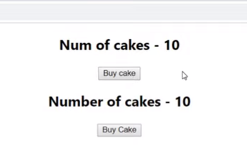

**Now lets implement the Dispatch function..**



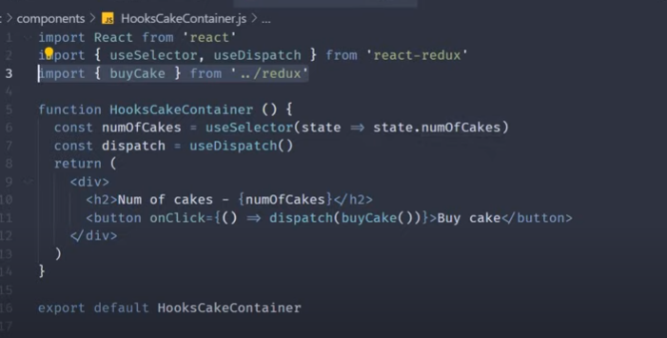

**With out connecting flow is defined and by using the hooks useSelector and useDispatch**

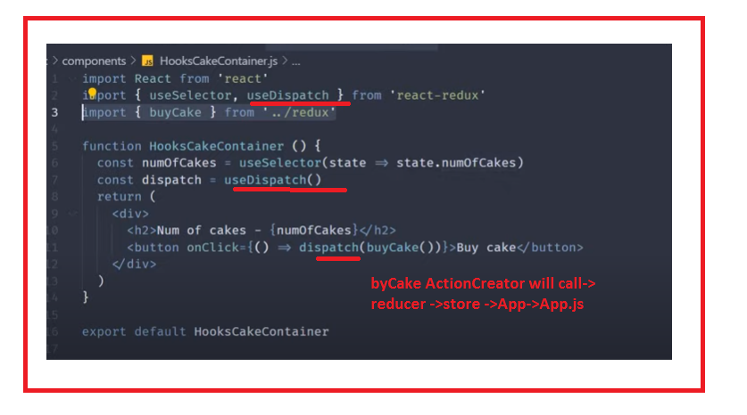

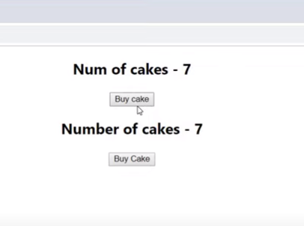

Its very pretty simple to use the hooks **useSelector** and **useDipstach** with the redux and how ever, few issues with the redux with the book need to view the documents for this..

<https://www.youtube.com/watch?v=fY-Wq0k_9P4&list=PLC3y8-rFHvwheJHvseC3I0HuYI2f46oAK&index=22>

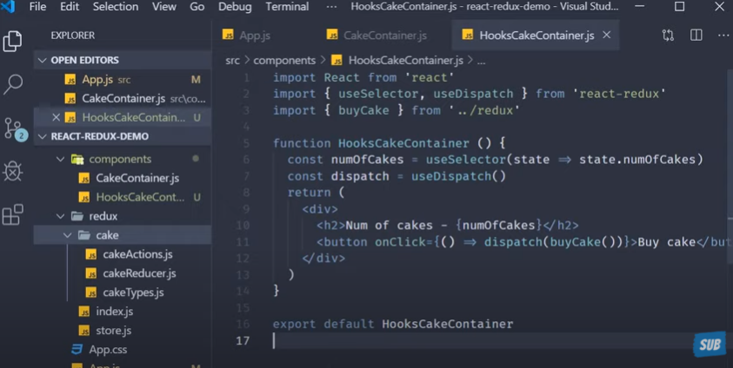

As in the above code-we have the **BuyCake() in the CakeType.js - Lets add the iceCream Folder –iceCreamActions, iceCreamReducer and iceCreamTypes.**

**Lets create the IceCreatemAction:- import iceCreamTypes**

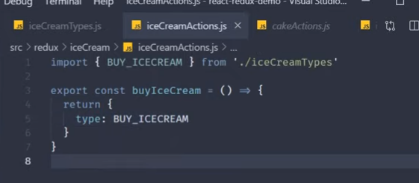

**Lets define in the index.js – which is there in the redux folder.**

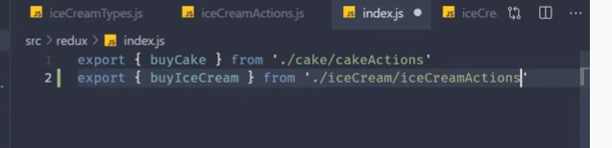

**Lets create the Ice Cream Reducer as we did the CakeReducer**

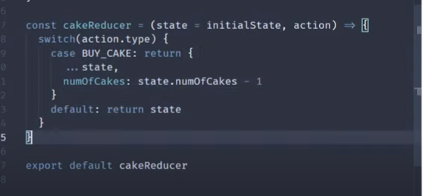

**IceCream Reducer**

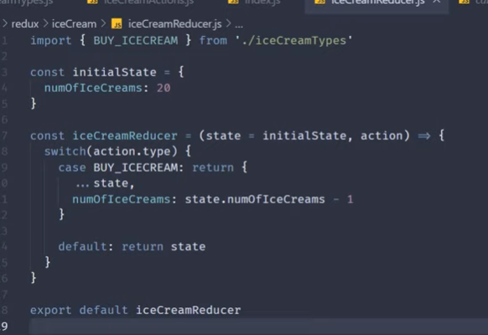

**Lets call the reducer in the store …. We have to two reducer and so combine reducers and pass to the store.**

**S1- combine the reducers**

**S2-create the store and call the combine reducer in it.**

**CombineReducer**

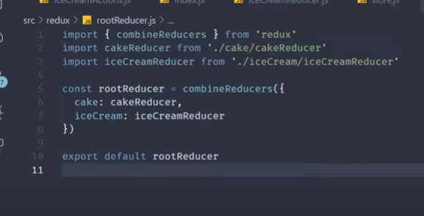

**Now lets create the iceCreamContainer .. without hooks. As we did in the Cake container eg:-**



**For iceCreamContainer**

**ActionCreators - replace numOfIceCream**

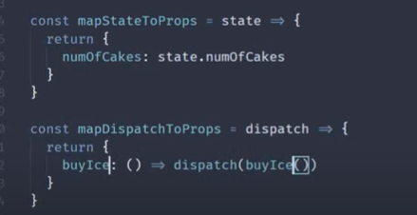

**Use connect to connect the actioncreators with the IceCreamContainer**

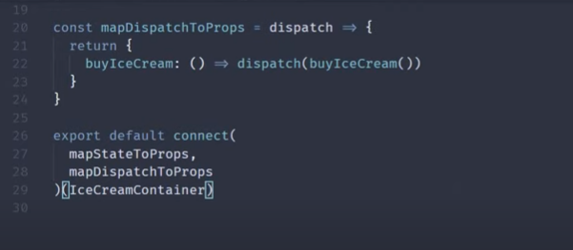

**Now Add the IceCreamContainer in App.js**

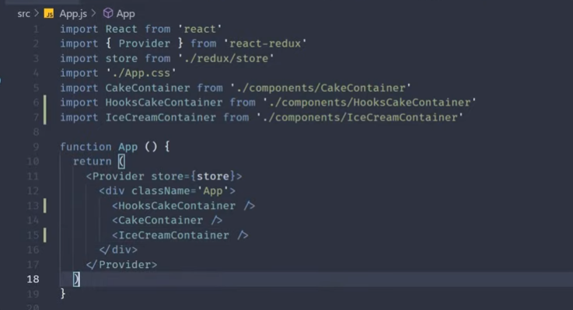

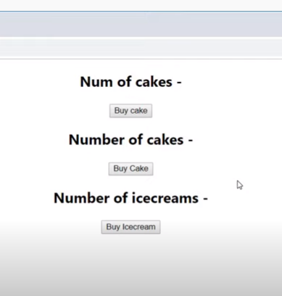

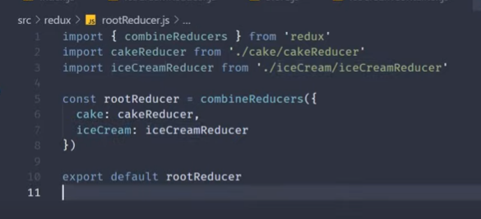

**Lets make change in the code.. IceCreamConainer…**

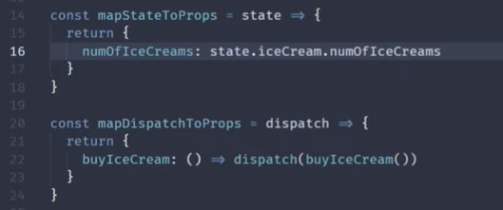

**Lets make change in the CakeContainer - in here code in the hooks**

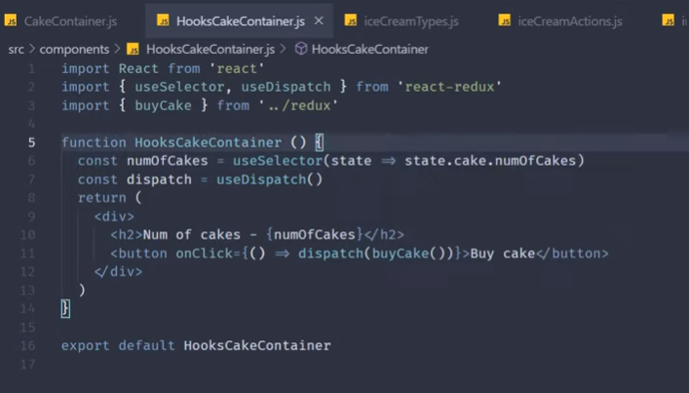

**Outpout**

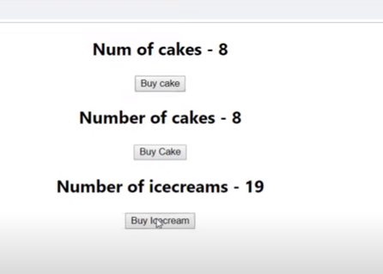

[**https://www.youtube.com/watch?v=6AGdeO28UKY&list=PLC3y8-rFHvwheJHvseC3I0HuYI2f46oAK&index=23**](https://www.youtube.com/watch?v=6AGdeO28UKY&list=PLC3y8-rFHvwheJHvseC3I0HuYI2f46oAK&index=23)

# Logger Middleware

**S1- Install npx I redux-logger –**

**In the below code where in store acceding the rootreducer adding the logger for actions..**

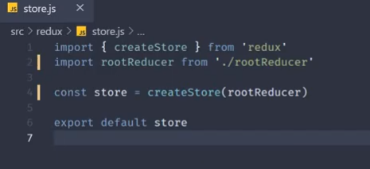

**S2- lets import in store.js file**

**Output :- go to inspect and – click on Num of Cakes..**

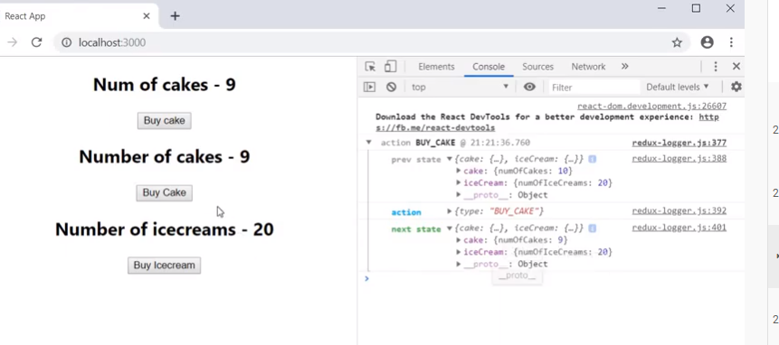

**You can view before state transition- noOfCakes is 10 and after transition –noofCakes is 9**

**Same in case of IceCream**

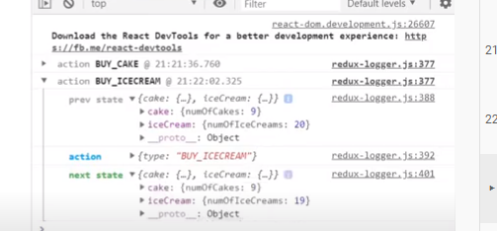

[**https://www.youtube.com/watch?v=IlM7497j6LY&list=PLC3y8-rFHvwheJHvseC3I0HuYI2f46oAK&index=24**](https://www.youtube.com/watch?v=IlM7497j6LY&list=PLC3y8-rFHvwheJHvseC3I0HuYI2f46oAK&index=24)

# Redux Devtool Extension

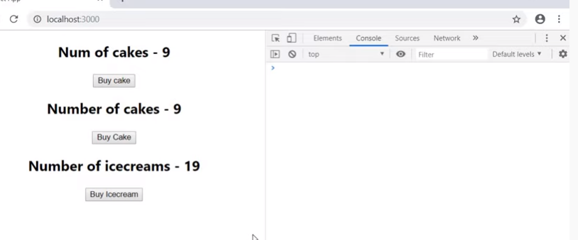

**Usage of Devtool Extension**

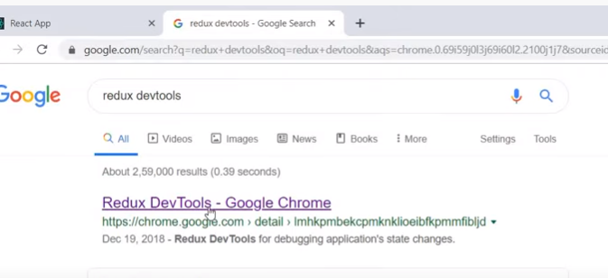

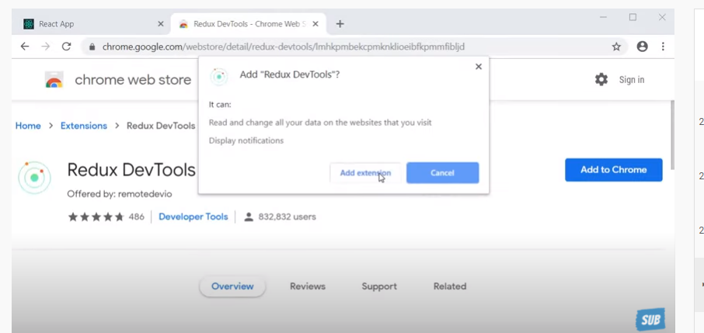

**On the browser :-**

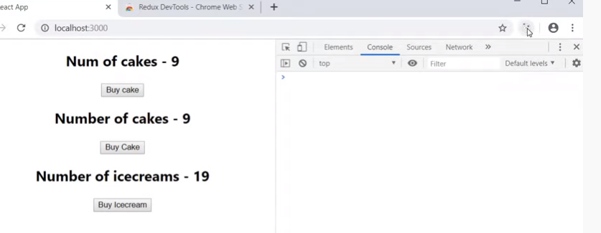

**Now add the extension tools to the react-redux app**

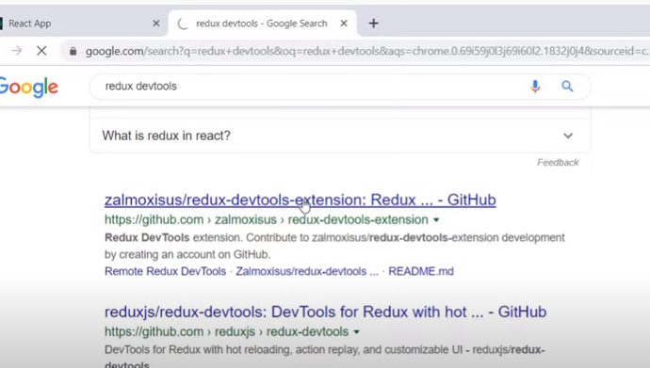

**Go to net and scroll the page and redux-devtools-extenions**

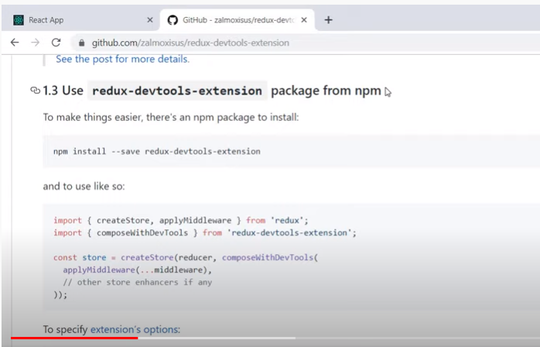

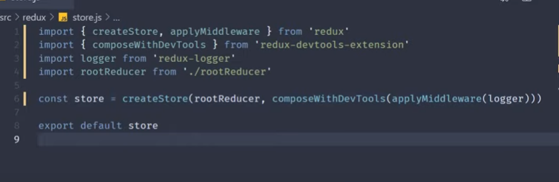

**See in the browser now..**

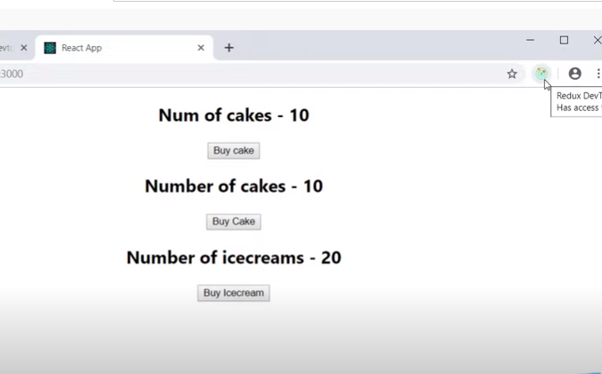

**Click on the icon –if you click on out it will disappeare**

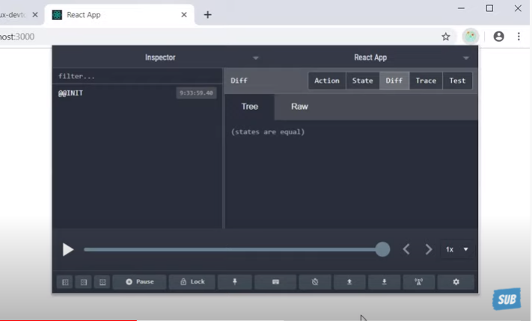

**Lets select redux tab -in inpsect**

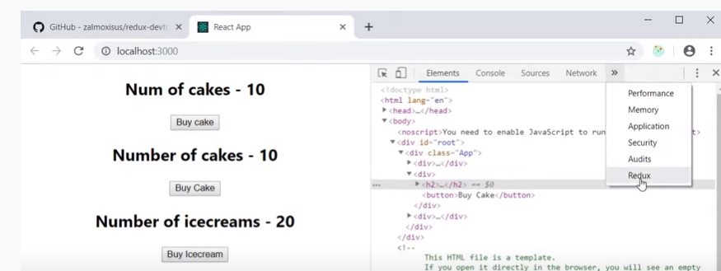

**Used in the debugging.**

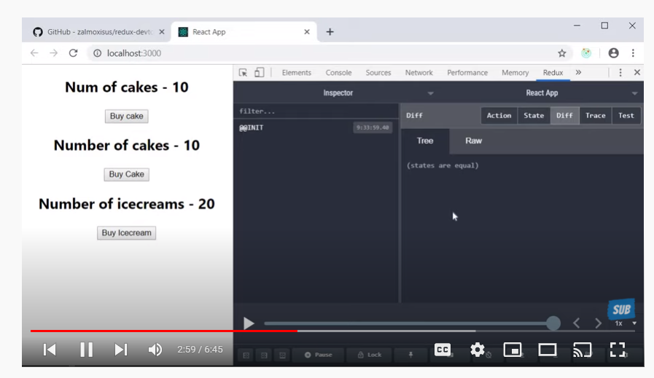

**Click on state**

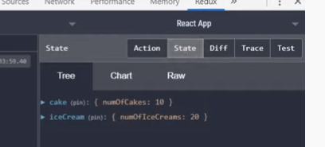

**When click on no of cakes**

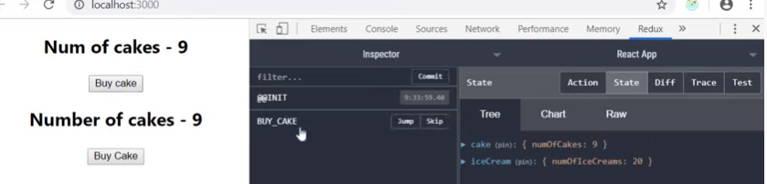

**When click on iceCream**

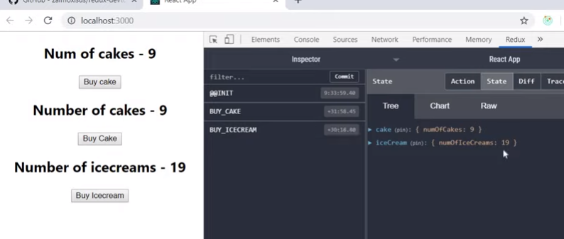

**You can view the Buy_Cake() –Action**

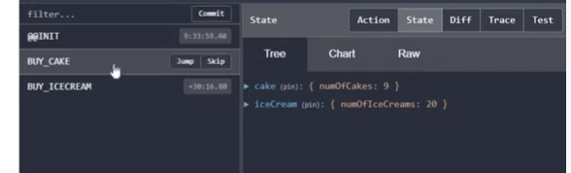

**You can view the Buy_IceCream**

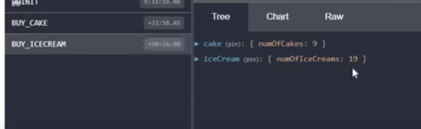

**When you click on Actions- You can see the type property and you will see more in the future**

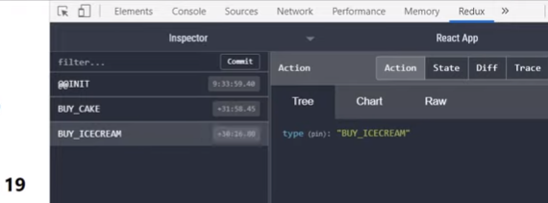

**Even there is no ui phase you can use below dispatch button –define the actiontype**

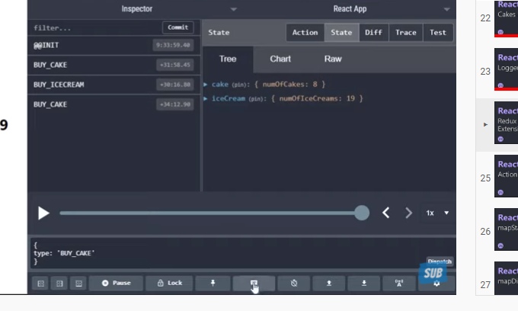

**When you click on the slider –which show all changes we have done.. You can move forward and backword**

[**https://www.youtube.com/watch?v=B-jNaEx1Xfc&list=PLC3y8-rFHvwheJHvseC3I0HuYI2f46oAK&index=25**](https://www.youtube.com/watch?v=B-jNaEx1Xfc&list=PLC3y8-rFHvwheJHvseC3I0HuYI2f46oAK&index=25)

# Action payload

**How to add the payload to the actionCreator**

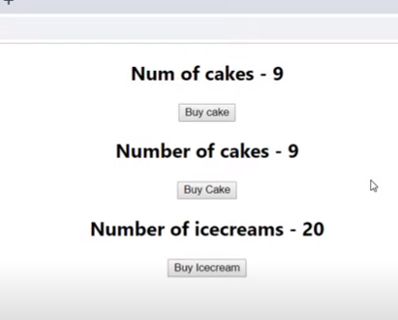

**As we know the buycake will only buy 1 same for iceCream-Now lets define the how many cakes we want to buy instead of 1?**

**We can achieve by using the hooks concepts like useState ..**

**NewCakeContainer**

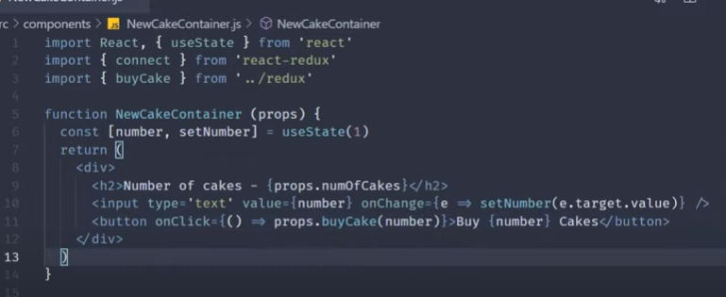

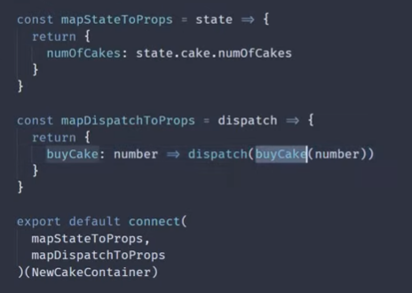

**Flow**

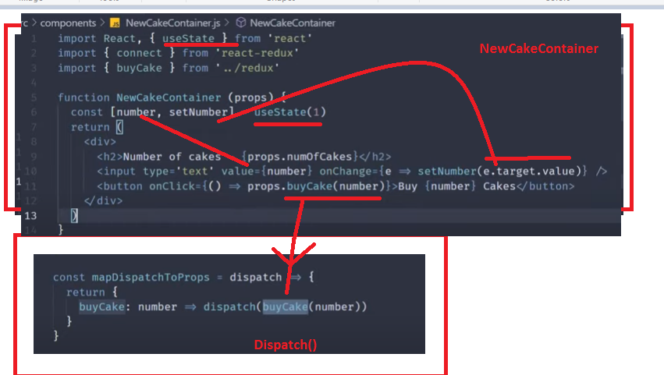

**ActionCreator – in which arugment is number passed and defeined (number = 1)- as not break the functionality because we are using the hook with redux..**

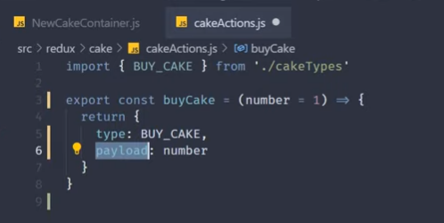

**Payload is convention name.. .**

**Lets make the change the Reducer too**

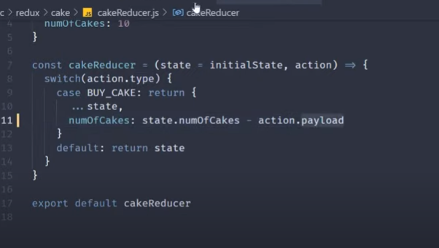

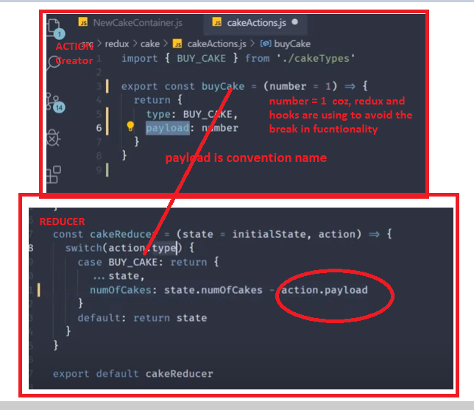

**Define- NewCakeContiner is**

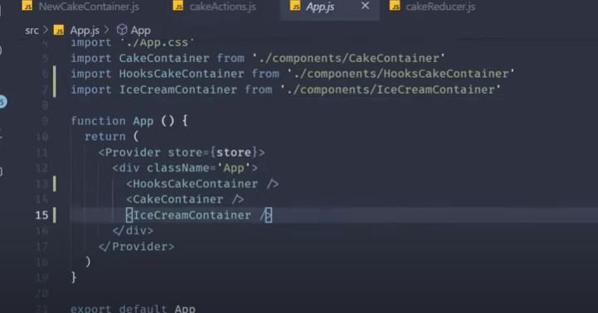

**By default input value is 1**



**So, you can random enter the number – how many cakes you want..**

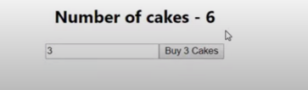

**Other components work with out break**

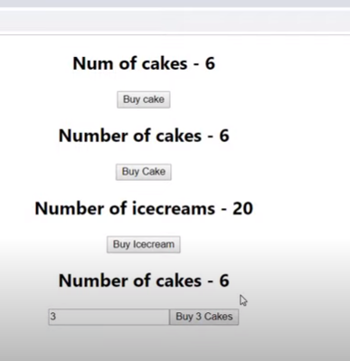

[**https://www.youtube.com/watch?v=prg6YzRcEvE&list=PLC3y8-rFHvwheJHvseC3I0HuYI2f46oAK&index=26**](https://www.youtube.com/watch?v=prg6YzRcEvE&list=PLC3y8-rFHvwheJHvseC3I0HuYI2f46oAK&index=26)

# mapStateToProps

**lets create the itemcontainer.. in the component.**

**Rfce- snipet of functional component -**

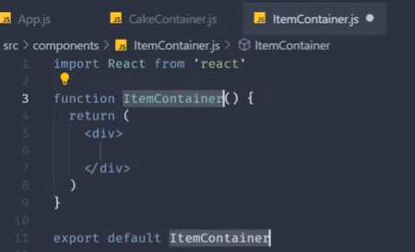

**As we have to re-use the itemContainer for both Cake container and IceCream container when passing the props.. by both containers**

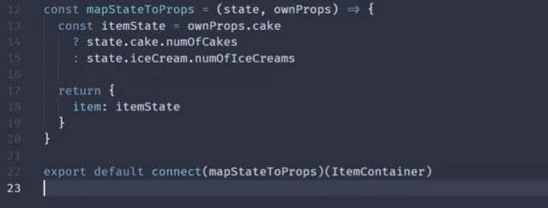

**Full code – connect, ownProps added in the mapStateToProps(state, ownProps)**

**ownProps.cake –for condition check and get output and however ,used rare case**

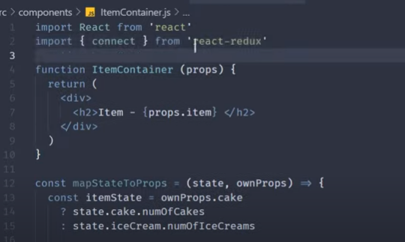

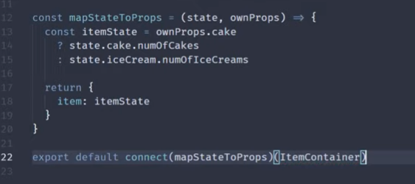

**Import connect .. connect the mapStateToProps to ItemContainer.**

**In App.js -define the itemContainer**

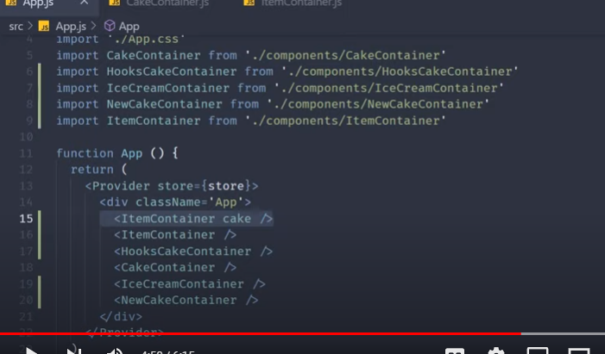

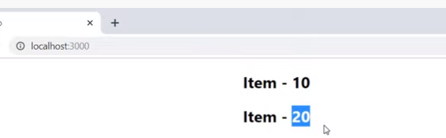

**Flow**

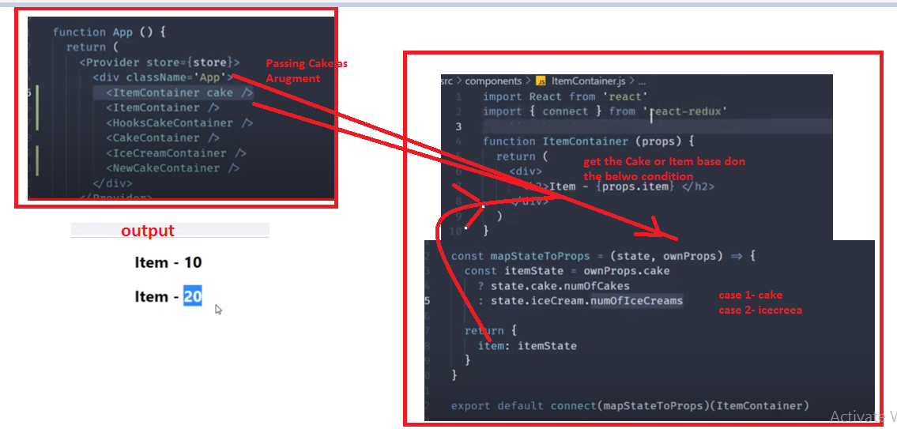

[**https://www.youtube.com/watch?v=gdNitBetNWc&list=PLC3y8-rFHvwheJHvseC3I0HuYI2f46oAK&index=27**](https://www.youtube.com/watch?v=gdNitBetNWc&list=PLC3y8-rFHvwheJHvseC3I0HuYI2f46oAK&index=27)

# mapDispatchToProps

**in itemContainer**

* **Import buyCake and BuyIceCream from the redux folder.**

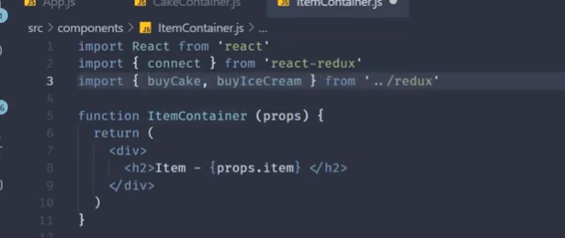

**mapStateToProps:-**

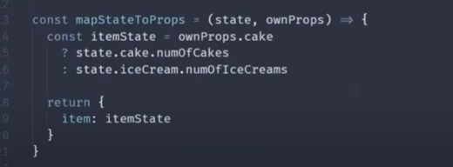

**mapDispatchToProps**

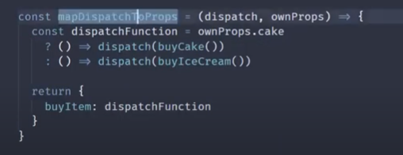

**Lets make change in the code in the ItemContainer**

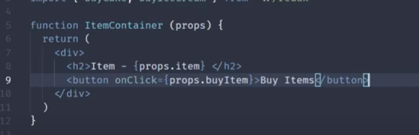

**Consider below flow**

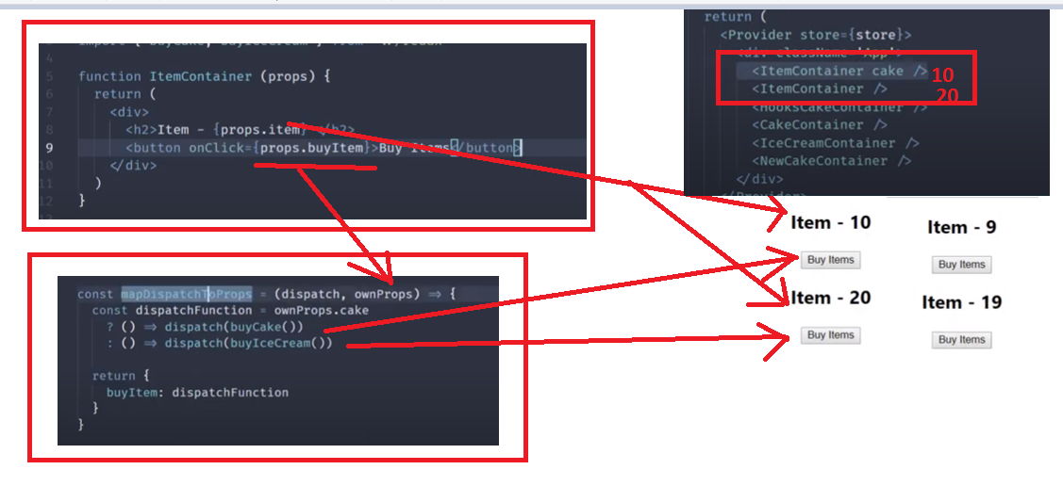

**Logic base done the ownProps… passing .. Cake- As we want not change the state of the mapStatetoProps and only mapDispatchtoProps. Then pass null for mapStatetoProps**

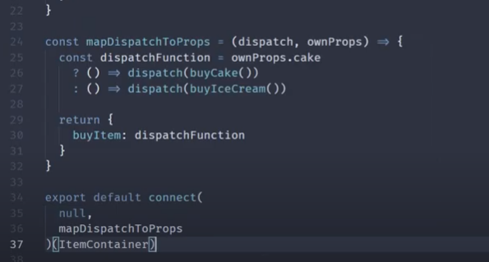

[**https://www.youtube.com/watch?v=tQ80uAyqVyI&list=PLC3y8-rFHvwheJHvseC3I0HuYI2f46oAK&index=28**](https://www.youtube.com/watch?v=tQ80uAyqVyI&list=PLC3y8-rFHvwheJHvseC3I0HuYI2f46oAK&index=28)

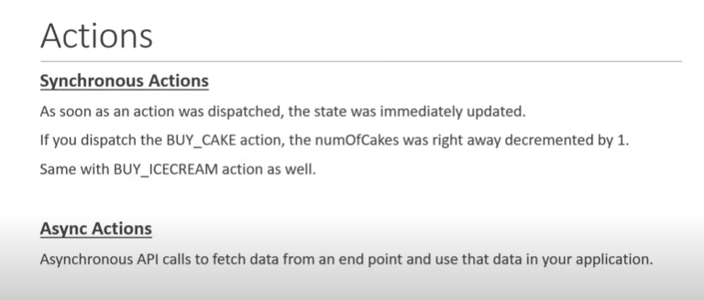

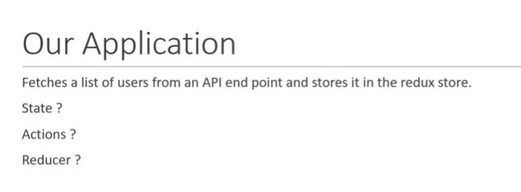

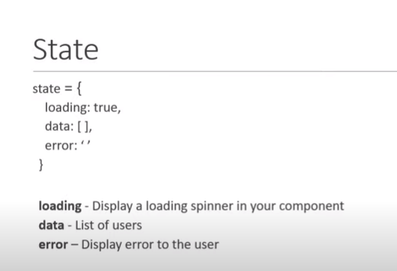

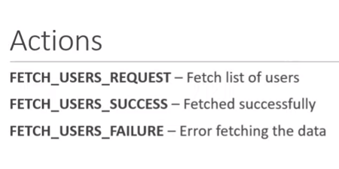

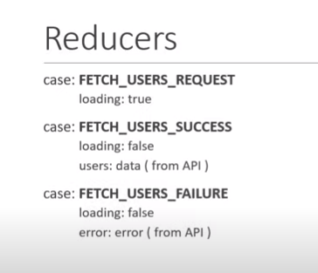

**Lets define UserContainer – Application**

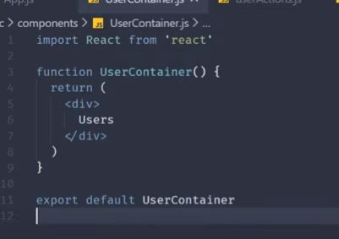

**User /ActionTypes**

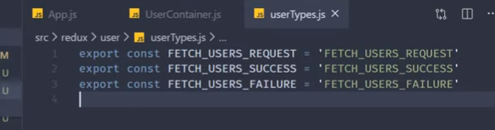

**User /ActionCreator - import the action types**

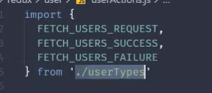

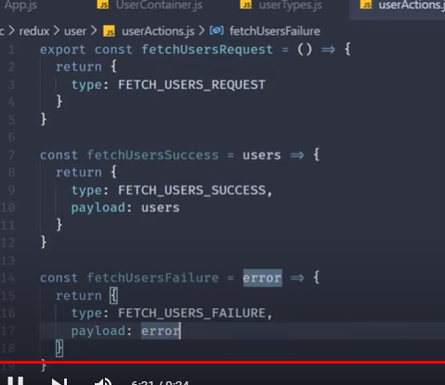

**Reducer : -**

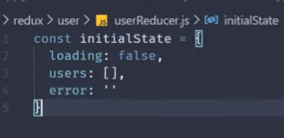

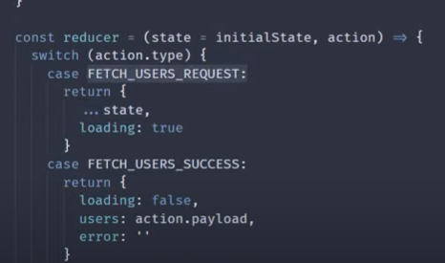

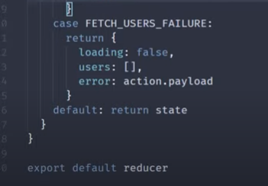

**As we have to export all ActionCreators.**

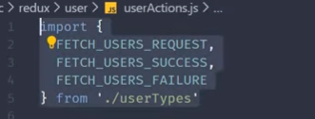

**So. Define index export all Action Creators**

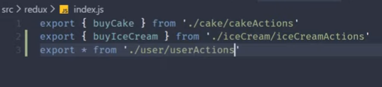

**Now define UserReducer in the combine Reducer**

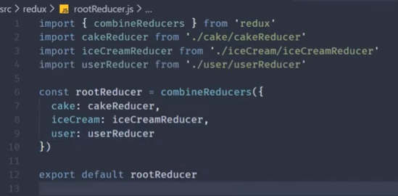

[**https://www.youtube.com/watch?v=tcCS4mGAq7Q&list=PLC3y8-rFHvwheJHvseC3I0HuYI2f46oAK&index=29**](https://www.youtube.com/watch?v=tcCS4mGAq7Q&list=PLC3y8-rFHvwheJHvseC3I0HuYI2f46oAK&index=29)

**lets call the Api..**

**s 1- install the axios and redux thunk –Asych Action Creator**

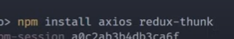

**S2- Import the in the store for the redux-thunk- Asych Action Creator**

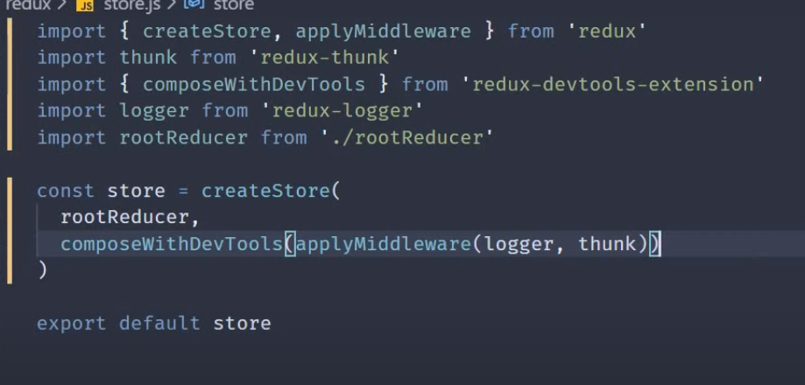

**S3-define Asych Action Creator**

**Lets define the UserAction.js –import the axios from redux**

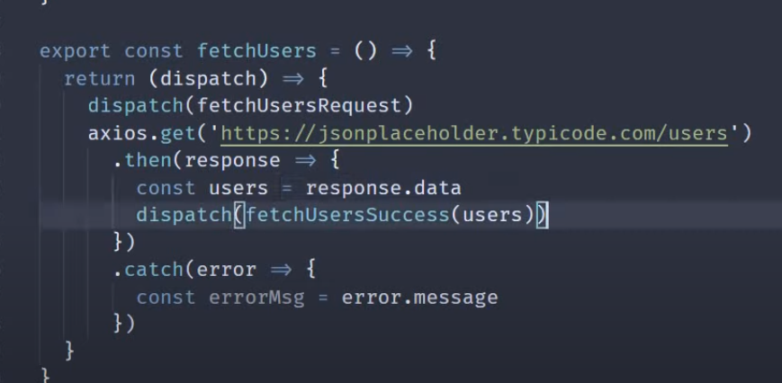

**Also define the Dispatch()-action for the failure..**

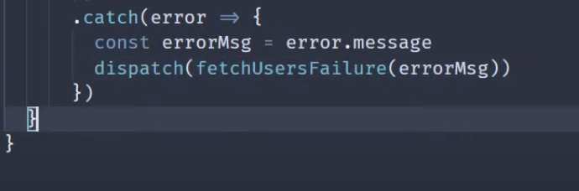

**All Dispatch Actions**

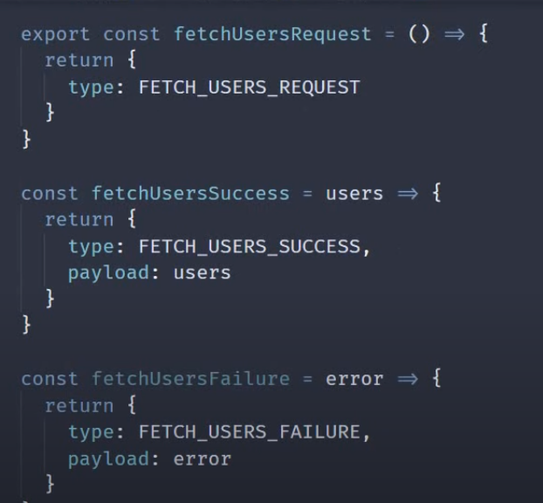

**Flow**

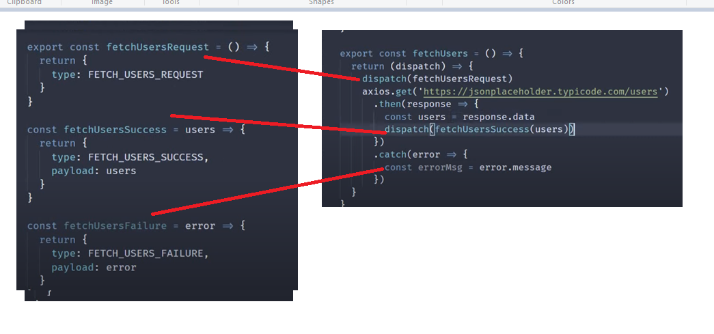

**Go to the User Container – import connect, UserEffect and FetchUser(Actions)**

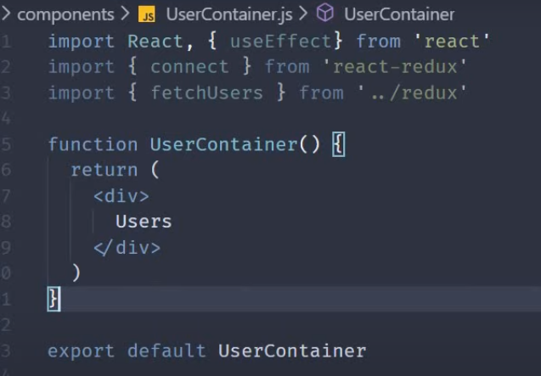

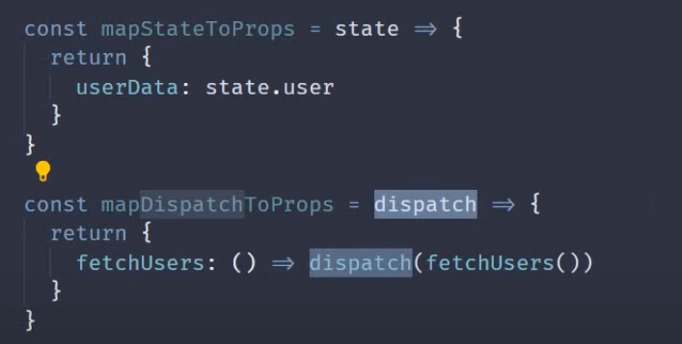

**Connect to UserContainer**

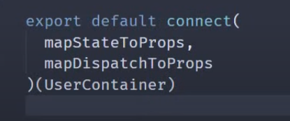

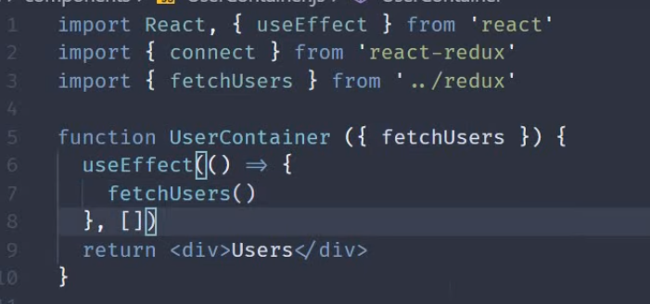

**As we are calling fetchUsers Actions.. [] –for one time – How to render the data ?**

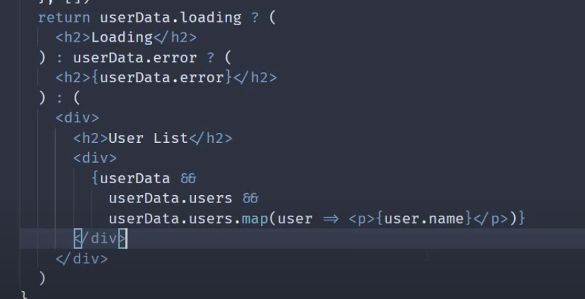

**Explaination – render the data -**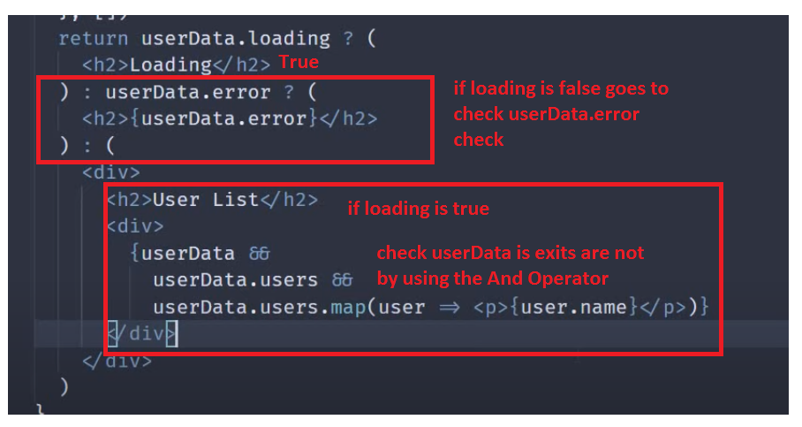

**App.js**

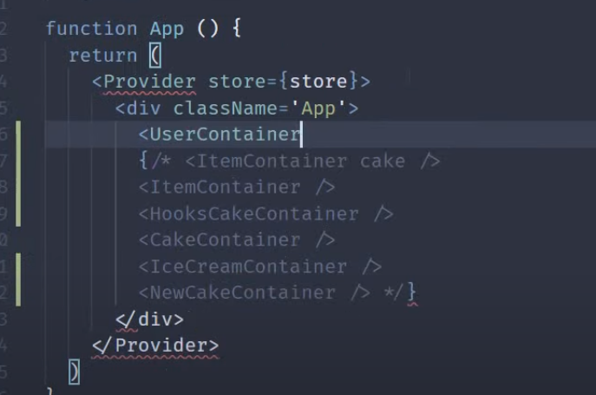

**Output :-**

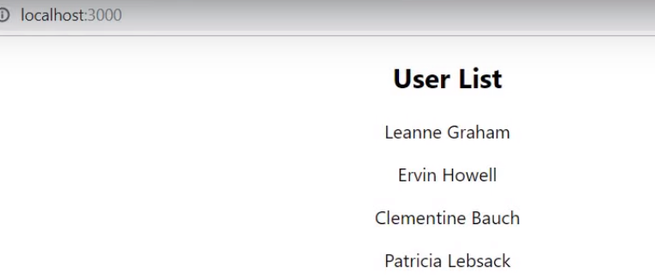

**Interview Questions**

[**https://www.youtube.com/watch?v=tfPq0iCJioQ&list=PLC3y8-rFHvwheJHvseC3I0HuYI2f46oAK&index=30**](https://www.youtube.com/watch?v=tfPq0iCJioQ&list=PLC3y8-rFHvwheJHvseC3I0HuYI2f46oAK&index=30)

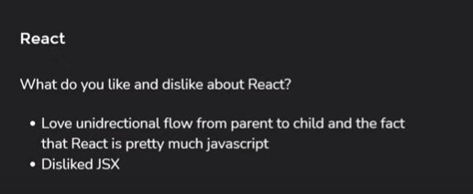

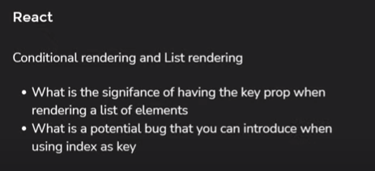

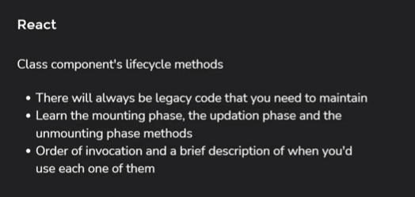

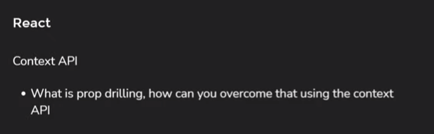

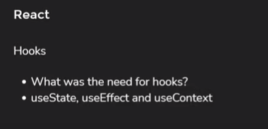

**For experience people**

